# **CHAPTER I**

**BACKGROUND OF THE STUDY**

# **Introduction**

Healthcare encompasses the organized provision of medical services, preventive care, and health promotion activities that work together to maintain and improve population health outcomes. Health centers serve as the primary point of contact between patients and healthcare services, making efficient record management essential for maintaining continuity of care and supporting public health initiatives (Srivastava et al., 2020). Healthcare record management is the foundation of quality medical service delivery, particularly in maternal and child health programs, where accurate tracking of prenatal visits and immunization schedules has a direct impact on patient outcomes. Effective recordkeeping systems enable healthcare providers to monitor patient progress, ensure continuity of care, maintain compliance with health protocols, and support evidence-based decision-making in clinical settings. The transition from traditional paper-based documentation to digital health information systems has become essential for healthcare facilities seeking to improve service quality and operational efficiency. Modern healthcare delivery increasingly depends on reliable information systems that provide real-time access to patient data while maintaining data security and supporting clinical workflows (Masuku, 2019). Digital health record systems, particularly in maternal and child health services, benefit from enabling the systematic tracking of prenatal care visits, vaccination schedules, and health outcomes across extended care periods.

The Rural Health Unit of Dumalinao in Zamboanga del Sur is a primary healthcare facility serving the municipality's diverse communities with essential health services, including maternal care and pediatric immunization programs. Established to provide accessible healthcare to rural populations, the facility has maintained its commitment to delivering preventive and curative services through various health programs mandated by the Department of Health. The health center is vital to the local healthcare infrastructure, providing essential medical services to residents across multiple barangays. It focuses particularly on maternal and child health initiatives that underpin the delivery of preventive healthcare in rural communities.

Currently, the health center relies on manual recordkeeping, with Barangay Health Workers maintaining handwritten logbooks to track patient information, appointment schedules, and immunization records. Healthcare staff manually enter patient names, ages, scheduled visits, and treatment remarks into physical logbooks. At the same time, prenatal and immunization tracking depend on entries made in Mother's Record Books and Immunization Cards that patients must bring to each visit. The monitoring process involves registering patients in logbooks, scheduling checkups and vaccinations, and conducting home visits when patients fail to appear at the center. Staff members rely on manual data entry in patient cards to track upcoming appointments, though this system often falls short of ensuring consistent patient follow-up. This manual data entry process is time-consuming and prone to human error, including illegible handwriting, incorrect data entry, and incomplete patient details (Endriyas et al., 2022).

According to Jessa Abella Macarate (personal communication, July 23, 2025), a Barangay Health Worker at the health center, the manual documentation system poses significant operational challenges that affect healthcare delivery and patient outcomes. She explained that one of their biggest struggles is keeping records by hand, noting that it takes considerable time and that mistakes are easily made. Macarate shared how difficult it is to find past patient data, describing how they often have to go through piles of documents or search through different files, which slows down their other essential tasks. The healthcare worker also mentioned that creating monthly reports is time-consuming, as they must collect data from multiple sources and carefully review everything. If they make even one mistake, they must start over, wasting valuable time on patient care. Additionally, patients often forget their appointment dates, despite manually entering them in their personal health records, which can lead to gaps in prenatal care and delayed immunizations. These operational inefficiencies create barriers to the effective delivery of maternal and child health services in the community.

A web-based prenatal and immunization record system addresses these challenges by providing digital access to patient profiles, appointments, and service histories. BHWs and health staff can register patients, update medical information, and monitor schedules from any device with internet access. Automatic notifications remind mothers of upcoming checkups or vaccinations via SMS, eliminating the appointment-tracking problems currently faced in the manual system (Louw et al., 2024). The digital platform eliminates the need to search through physical logbooks, ensuring patient records remain accessible even when staff are unavailable or documents are misplaced. Digital health record systems have demonstrated effectiveness in community health settings by reducing appointment dropouts, improving patient follow-up rates, and enabling healthcare workers to manage larger patient loads more efficiently (Sarkar et al., 2020). Healthcare workers can automatically generate monthly reports from the system database, eliminating the time-consuming process of manually collecting and verifying data across multiple sources.

This digital transformation represents a strategic advancement in rural healthcare delivery that aligns with modern health information system standards while addressing the specific operational needs of the Dumalinao health center. By replacing manual processes with an integrated web-based platform, the system will enhance the quality of maternal and child health services while reducing administrative burden on healthcare staff. The implementation will ensure data security and operational continuity, supporting the health center's mission to provide reliable, accessible healthcare services to the community.

**Project Context**

This project addresses inefficiencies in manual prenatal and immunization record management at the Rural Health Unit of Dumalinao, including physical record storage and tracking issues experienced by healthcare workers and patients. The Barangay Health Workers, midwives, and nurses using this system will be able to manage patient records digitally and provide real-time updates on appointments and immunization schedules, eliminating the need for handwritten logbooks. Additionally, the healthcare facility can transition from traditional paper-based recordkeeping to a digital approach, reducing administrative workload and eliminating the risk of lost or damaged patient records. Prenatal and immunization record management in a healthcare facility aims to create a system that maximizes efficiency and meets quality standards while operating under operational constraints. Implementing a web-based prenatal and immunization monitoring system will enable tracking of patient care and the digital storage of health records, addressing concerns about slow processing and poor communication among healthcare workers and patients.

The proposed system will provide a digital platform and communication tool to assist midwives, nurses, and barangay health workers in managing their patient care responsibilities with greater ease and simplicity. Healthcare workers can track patient progress in real time, automatically send appointment reminders, and access complete patient histories without searching through physical files. Meanwhile, patients will receive timely notifications about their scheduled checkups and vaccinations, reducing missed appointments and ensuring continuity of care.

# **Purpose and Description**

This research aims to develop a web-based prenatal and immunization monitoring system, providing healthcare workers with efficient patient record management and a digital platform for tracking maternal and child health services. With this system, healthcare facilities can streamline patient monitoring, store patient health records, and reduce administrative burdens.

The system requires user authentication and role-based access to ensure data security and appropriate system usage.

*1. Midwife.* Has the ability to oversee prenatal care monitoring and manage patient appointments effectively. The digital platform enables midwives to access complete patient histories, schedule follow-up visits, and track pregnancy progress.

*2. Barangay Health Worker.* Through mobile access to the web-based platform, the worker can register new patients, conduct home visits with updated patient information, and efficiently maintain community health records.

**Objectives**

### This research aims to develop and implement a secure, web-based system that enables real-time input and management of prenatal checkup records and child immunization data for the Dumalinao Health Center. This system would allow healthcare workers to monitor patient care effectively, track immunization schedules, and ensure that maternal and child health records are preserved digitally for continuous healthcare delivery.

### **Specific Objectives**

### The researcher's specification aims to:

1. To identify the process of managing prenatal and immunization records and patient monitoring in the healthcare facility.
2. To design and develop a web-based system to monitor prenatal care and immunization tracking while maintaining digital patient records.
3. To evaluate the system's functionality, reliability, and usability in real-world healthcare scenarios by conducting user testing and gathering feedback from healthcare workers and patients.

## **Scope and Limitation**

The proposed system is a web-based prenatal and immunization monitoring platform that enables healthcare workers to manage patient records and track maternal and child health services at the Rural Health Unit of Dumalinao. Healthcare workers can create patient profiles and monitor progress throughout the care cycle by utilizing features such as user registration, secure login, and patient tracking. After logging in, the platform displays available services, allowing healthcare workers to access patient records, schedule appointments, and update medical information. The midwife and Barangay Health Workers can approve or update patient care plans accordingly. Patients can receive updates about their appointment schedules and vaccination reminders through the notification system. Additionally, the system features appointment scheduling, immunization tracking, and reporting capabilities.

The system will focus specifically on prenatal care and immunization tracking for the Rural Health Unit of Dumalinao, which requires internet connectivity for all operations and depends on SMS gateway services for patient notifications. The platform will be limited to maternal and child health services currently provided by the healthcare facility. The system maintains digital records of prenatal and immunization data that the law allows to be stored electronically. The system will not replace required paper documentation where legal requirements mandate physical record retention; however, it will serve as a supplementary digital platform for improved access and processing efficiency. General medical consultations, emergency care services, and other healthcare programs are closely related medical operations. However, this project will not include them as they serve different healthcare purposes and require separate system architectures. The system will not incorporate telemedicine features such as video consultations or remote patient monitoring, as these components are beyond the scope of this project and would require additional development resources and complexity that may impact the core functionality and timeline of the prenatal and immunization monitoring system.

**Definition of Terms**

1. *Barangay Health Worker (BHW)*. A community healthcare worker who registers patients, conducts home visits, and maintains community health records using the system.
2. *Digital Record Management*. The process of storing patient healthcare information electronically for easy access and management.
3. *Immunization Card*. The physical record showing a child's vaccination history and scheduled immunizations.
4. *Immunization Tracking*. Digital monitoring of vaccination schedules, records, and compliance for pediatric patients.
5. *Mother's Record Book*. The official documentation of prenatal care visits and medical assessments during pregnancy.
6. *Notification System*. Automated alerts are sent via SMS to inform patients about appointments, vaccinations, and follow-up care.
7. *Patient*. The digital system tracks pregnant women and children who receive prenatal care and immunization services.
8. *Web-based Prenatal Monitoring*. Digital tracking and management of pregnancy-related healthcare appointments and medical assessments conducted online.

**CHAPTER III**

**DESIGN AND METHODOLOGY**

**3.1 Overview**

The developers created a Web-Based Monitoring and Recordkeeping System for Prenatal Care and Immunization System to help barangay health workers and midwives by making their work easier and less time-consuming. This chapter explains the step-by-step process followed by the researchers to complete the project study. The researchers employed an SDLC model to guide the system's development, ensuring careful planning and execution.

The developers designed the Web-based Record Keeping and Monitoring system for prenatal and immunization purposes. This system replaces manual tasks and paper records with a digital platform that enables healthcare staff to record patient information, track appointments, and monitor immunization schedules in real time. It also helps solve problems with storing and finding records while preventing the loss or damage of essential files. Ultimately, the system enhances the delivery of maternal and child healthcare by streamlining services, making them more organized, reliable, and efficient, even with limited resources in local health centers.

* 1. **Research Methodology**

To ease the workload of barangay health workers and midwives, the developers designed a Web-Based Monitoring and Recordkeeping System for Prenatal Care and Immunization that streamlines processes and saves valuable time. The proponents will use the Waterfall methodology to develop the Monitoring and Recordkeeping System for Prenatal Care and Immunization. A waterfall process is linear and sequential, where developers must complete each phase before moving to the next. This approach ensures that developers define requirements at the start and that each step flows logically into the next. Using this approach, developers can systematically plan, design, develop, test, and deploy the system in a structured manner, minimizing the risk of confusion and ensuring a stable outcome. The developers chose the Waterfall method because it provides a clear framework that emphasizes documentation, thorough planning, and a step-by-step process suited to the needs of barangay health centers.

**Figure 3**

*Waterfall Model for Software Development Life Cycle*

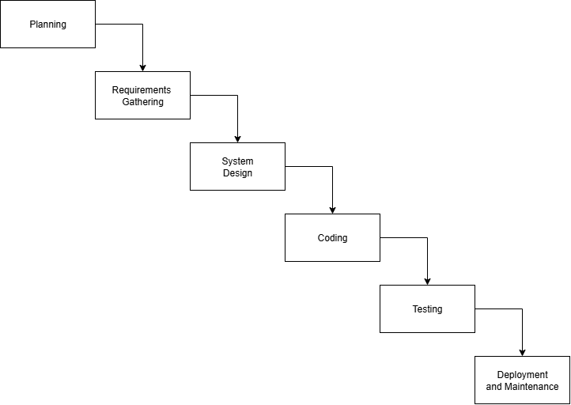

**3.3 Planning**

During this stage, the proponents plan to conduct stakeholder consultations at Barangay Mecolong Health Center to identify challenges in the current recordkeeping process. The planning activities focus on assessing the limitations of the manual system, including delays, incomplete records, and difficulties in monitoring patient care. The team will also gather the essential criteria for developing a reliable system while considering the center's available resources and existing workflows. Discussions with healthcare staff, including the midwife, aim to highlight the center's operational needs. The goal is to create a clear roadmap that supports the health center's transition from manual documentation to a more systematic and efficient digital process.

**3.4 Requirements Gathering**

In this phase, the proponents first identified the problems in the barangay health center that affect recordkeeping. To achieve this, they conducted interviews with health workers to gather insights into the issues they encounter and their preferences for a new system. The researchers assessed the situation and listed the functional and nonfunctional requirements by asking questions about the areas of most significant concern. To address concerns, the developers organized meetings to develop an action plan and establish the system's architecture and design. The developers gathered and reviewed, which helped the researchers identify technical gaps in the current setup and potential organizational challenges. The developers kept this process simple so that everyone involved could understand it. To improve the system's performance, the researchers worked together to define the functional and technical requirements that would serve as the foundation for design and development.

* + 1. **Functional Requirements**

**3.4.1.1 Log in Health Workers**

The system requires all Midwives and Barangay Health Workers (BHWs) to log in before use. The system administrator will provide each health worker with a username and password.

The system shall check the entered credentials and allow access only when the username and password are correct. The system shall reject invalid login attempts.

**Functions**

* The system allows authorized users to log in using their assigned credentials.
* The system shall deny access to any unauthorized or invalid login attempt.

**3.4.1.2 User Management**

Role-based access control: Midwives with complete monitoring access and immunization privileges, and BHWs with limited functions such as patient registration and record updates.

**Functions**

* A midwife can view the complete list of registered users in the system.
* The midwife can create new user accounts when needed.
* A midwife can search accounts by identifiers to quickly find users' details.
* A midwife can view the user details, which include full name, age, gender, contact number, date created, and address.
* A midwife can edit and update user information.
* A midwife can deactivate and activate users' accounts.

**3.4.1.3 Dashboard for Health Worker**

The Dashboard provides health workers with a quick view of key information, including child records, immunization schedules, and vaccine details. It helps the record-in-charge monitor the progress of immunization services and prenatal monitoring.

**Functions**

* Displays counting cards (e.g., total registered mothers, total registered children, total vaccines given).
* Displays a 2D bar chart showing the number of registered parents.
* The system displays a pie chart for immunization coverage.
* The chart shows the number of prenatal checkups performed each month.
* Displays a list of upcoming appointments (prenatal visits and child immunizations).

**3.4.1.4 Patient Registration and Profile Management**

In this Module, Healthcare workers can register new patients, update their details, and maintain complete digital records for pregnant women and children. This module ensures accurate, organized, and secure record keeping.

**Function**

* Barangay Health Workers and Midwives can register new patients directly into the database.
* A midwife can edit and update patient records when needed.
* Midwife Store and retrieve patient histories, including prenatal visits and immunization schedules.

**3.4.1.5 Prenatal Care Monitoring**

This module enables healthcare staff to record, monitor, and track the progress of pregnancy from the initial checkup through to delivery.

**Function**

* The midwife records each patient's prenatal checkups digitally.
* The midwife schedules and manages follow-up checkups.
* A midwife monitors the progress of pregnancy at every stage.

**3.4.1.6 Immunization Tracking**

This module would help healthcare workers record, track, and remind patients about their child's immunizations to ensure timely vaccination.

**Function**

* The midwife recorded completed vaccinations in the system.
* Midwife Track vaccination status (completed vs. pending).

**3.4.1.7 Reporting**

This module automates the generation of reports required by health centers for compliance and monitoring.

**Function**

* Midwives can generate monthly automated reports on prenatal visits, immunizations, and patient attendance.
* The system provides bar, column, and pie charts for data visualization.
* Users can export reports into PDF or Excel formats for printing.

**3.4.1.8 Notifications and Reminders**

This module sends timely alerts to patients, ensuring continuous and effective healthcare delivery.

**Function**

* The system automatically sends SMS reminders for scheduled prenatal checkups and immunizations.
* The system notifies Midwives and barangay health workers about missed follow-up appointments.

**3.4.1.9 Cloud Backup**

This module lets midwives safeguard clinical records through an on-demand, web-based backup workflow that keeps care continuity intact even if local devices become unusable.

**Function**

* The system provides a manual backup control that lets midwives trigger encrypted uploads of patient charts, and activity records to the cloud whenever needed.
* Midwives can initiate restoration of the most recent cloud-stored snapshot after hardware loss or data corruption.
* The system confirms each backup or restore attempt and reports any failures so midwives can retry or seek support promptly.
  + 1. **Nonfunctional Requirements**

1. **Usability**

The system must prioritize usability to ensure smooth adoption and efficient use by healthcare workers. An intuitive and user-friendly interface is essential, particularly because users may have varying levels of technical proficiency. The system shall allow the record-in-charge to operate it without any required training. Its interface should be self-descriptive and straightforward, making it easy to understand and use correctly after just one attempt.

1. **Performance**

The system must operate smoothly in real-world settings to ensure reliable and efficient healthcare services. Fast access to patient records with minimal waiting time is essential because timely information supports better decisions and quicker service. The system allows healthcare staff to update and view records, preventing care delays immediately.

1. **Reliability**

The system shall provide 85% uptime and protect data integrity through regular backups and recovery mechanisms. It must also ensure consistent record updates and rapid restoration of prenatal and immunization services during interruptions.

1. **Functionality**

The system shall support patient information management, prenatal monitoring, and immunization tracking with automated schedules and alerts. It shall allow quick record retrieval, generate summary reports, and provide user account management to ensure efficient healthcare service delivery.

1. **Design of System Software, Product, and Processes**

The developers designed the proposed web-based prenatal and immunization records system using the SDLC to ensure a structured approach. It replaces manual logbooks with a secure digital platform that enables real-time data entry, appointment scheduling, and automated SMS notifications. Key features include patient registration, digital records, immunization tracking, and computerized reports, with role-based access for healthcare staff. The system features a user-friendly, responsive design that works seamlessly across desktop and mobile devices, streamlining workflows, reducing administrative tasks, and enhancing the accuracy and reliability of maternal and child health services.

* 1. **System Design**

In this phase, the proponents focused on visualizing the system design based on the gathered requirements. They began by sketching the initial layout to show the intended functions and demonstrate how the system would work. The developers designed the user interface to be intuitive and straightforward, ensuring a seamless user experience. To better illustrate the process, the researchers created diagrams that mapped out the user flow and highlighted areas requiring human interaction. They also prepared screen designs using PHP, Laravel Framework, and MySQL to show how the system would present information and interact with users. Once the developers had completed these designs, the researchers presented them to the system administrator for feedback and further discussion.

* + 1. **Behavioral Diagrams**

**3.5.1.1 Use Case Diagram**

**Figure 4**

*Use Case for A Web-Based System for Prenatal and Immunization Records*

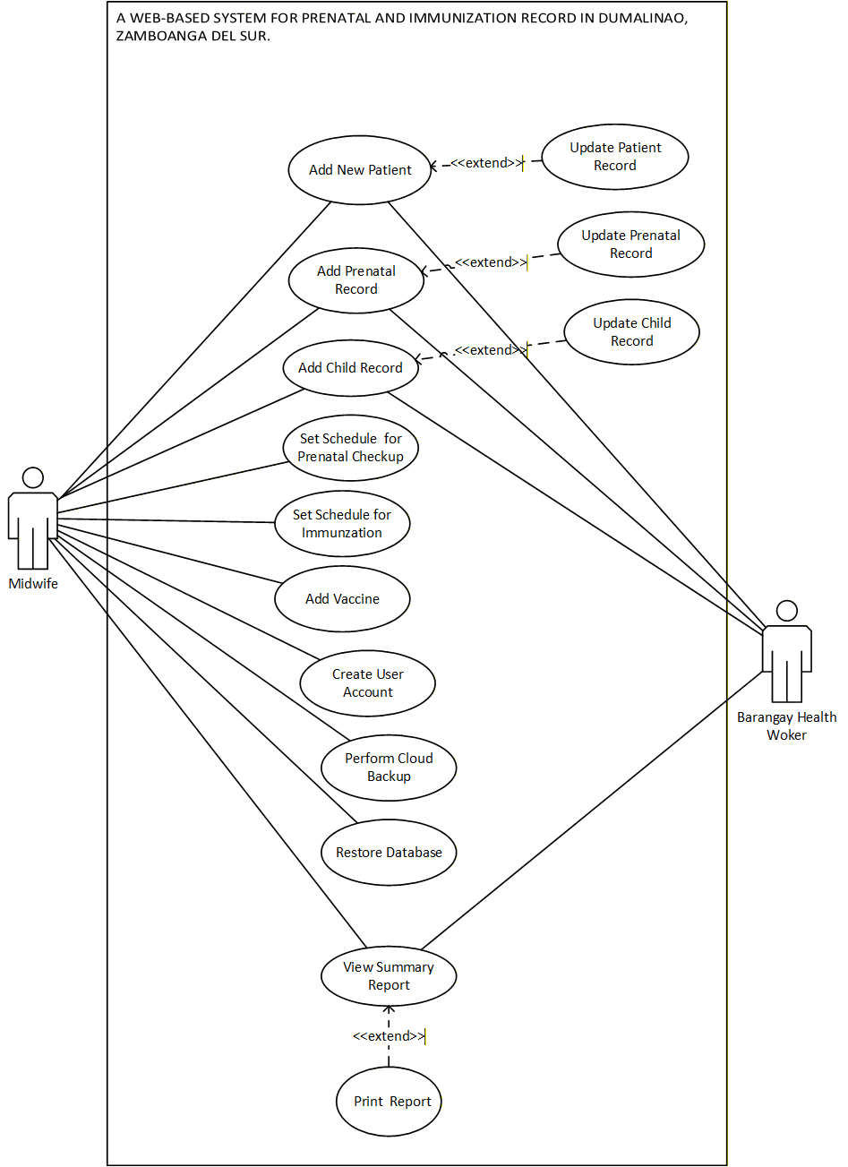

**3.5.1.2 Use Case Narrative**

**Table 1**

*Use Case Narrative for Add New Patient*

|  |  |  |
| --- | --- | --- |
| **Use Case Name** | Add New Patient | |
| **Actor(s)** | Midwife, Barangay Health Worker | |
| **Description** | This use case allows the Midwife to add new patients to the system. | |
| **Main Sequence** | **Actor Action** | **System Response** |
|  | Step 1: The actor clicks the “Patient Registration” button in the menu.  Step 3: The actor clicks the “Register New Patient” button.  Step 5: The Actor inputs the patient's details.  Step 6: The actor clicks the “Register Patient” button. | Step 2: The system responds by displaying the patient’s records.  Step 4: The System displays the Register Patient form.  Step 7: The system saves the patient information to the database. |
| **Alternative**  **Sequence** | Step 5: The actor clicks “Cancel” button. | Step 6: The System will return the actor back to the patient registration page. |
| **Precondition** | The actor must have the patient’s information. | |
| **Postcondition** | New Patient has successfully been added. | |

**Table 2**

*Use Case Narrative for Update Patient Record*

|  |  |  |
| --- | --- | --- |
| **Use Case Name** | Update Patient Record | |
| **Actor(s)** | Midwife, Barangay Health Worker | |
| **Description** | This use case enables the midwife and the barangay health worker to edit and update patient records. | |
| **Main Sequence** | **Actor Action** | **System Response** |
|  | Step 1: The actor clicks the “Patient Registration” menu.  Step 3: The actor clicks the search bar.  Step 4: The actor inputs the patient’s name.  Step 6: The actor clicks the “Edit” button.  Step 8: The actor modifies patient information.  Step 9: The actor clicks the “Update Record” button. | Step 2: The system displays the list of registered patients.  Step 5: The system displays the filtered search results.  Step 7: The system displays the patient details form.  Step 10: The system saves the modified patient record into the database. |
| **Alternative**  **Sequence** | Step 9: The actor clicks the “Cancel” button. | Step 10: The system discard changes and return the actor to the search results page without saving changes. |
| **Precondition** | The actor must access the system. | |
| **Postcondition** | Patient’s record has been updated successfully. | |

**Table 3**

*Use Case Narrative for Add Prenatal Record*

|  |  |  |
| --- | --- | --- |
| **Use Case Name** | Add Prenatal Record | |
| **Actor(s)** | Midwife | |
| **Description** | This use case allows the Midwife to enter new prenatal data into the system. | |
| **Main Sequence** | **Actor Action** | **System Response** |
|  | Step 1: The actor clicks the “Prenatal Care” menu.  Step 3: The actor selects the “Prenatal Records” sub-menu.  Step 5: The actor clicks the “Add Prenatal Record” button.  Step 7: The actor enters the prenatal details.  Step 8: The actor clicks the “Save Record” button. | Step 2: The system displays the sub-menu options.  Step 4: The system displays the list of prenatal records.  Step 6: The system displays the Prenatal Record information form.  Step 9: The system saves the prenatal information record to the database. |
| **Alternative**  **Sequence** | Step 8: The actor clicks the “Cancel” button. | Step 9: The system will return the actor back to the prenatal records page. |
| **Precondition** | The actor must have access to the system. | |
| **Postcondition** | Prenatal information has been successfully recorded. | |

**Table 4**

*Use Case Narrative for Update Prenatal Record*

|  |  |  |  |
| --- | --- | --- | --- |
| **Use Case Name** | Update Prenatal Record | | |
| **Actor(s)** | Midwife, Barangay Health Worker | | |
| **Description** | This use case allows the Midwife to update prenatal record information. | | |
| **Main Sequence** | **Actor Action** | | **System Response** |
|  | Step 1: The actor selects the “Prenatal Records” sub-menu.  Step 3: The actor clicks the search bar and enters the patient’s name.  Step 5: The actor clicks the “Edit” button for the chosen record.  Step 7: The actor modifies prenatal details.  Step 8: The actor clicks the “Update Record” button. | | Step 2: The system displays the list of prenatal records.  Step 4: The system displays the filtered search results.  Step 6: The system displays the Prenatal Record form pre-filled with details.  Step 9: The system saves the modified prenatal record to the database. |
| **Alternative**  **Sequence** | | Step 8: The actor clicks the “Cancel” button. | Step 9: The system will return the actor back to the results page. |
| **Precondition** | | The actor must access to the system. | |
| **Postcondition** | | Prenatal information has successfully updated. | |

**Table 5**

*Use Case Narrative for Add Child Record*

|  |  |  |
| --- | --- | --- |
| **Use Case Name** | Add Child Record | |
| **Actor(s)** | Midwife | |
| **Description** | This use case enables Midwives and Barangay Health Workers to enter new child records, including child record details. | |
| **Main Sequence** | **Actor Action** | **System Response** |
|  | Step 1: The actor clicks the “Immunization Tracking” menu.  Step 1: The actor clicks the “Child Records” submenu.  Step 5: The actor clicks the “Add Child Record” button.  Step 7: The actor selects the preferred option (existing mother or new mother).  Step 9: The actor enters the child's details.  Step 10: The actor clicks the “Save Record” button. | Step 2: The system displays the submenu options.  Step 4: The system displays the list of existing child records.  Step 6: The system displays a dialog asking if the mother already exists in the records.  Step 8: The system displays the Child Information Form.  Step 11: The system saves the child's record in the database. |
| **Alternative**  **Sequence** | Step 10: The actor may click the “Cancel” button at any point. | Step 11: The system returns the actor to the Child Records list page. |
| **Precondition** | The actor must have the child’s information. | |
| **Postcondition** | Child information has been successfully registered. | |

**Table 6**

*Use Case Narrative for Update Child Record*

|  |  |  |
| --- | --- | --- |
| **Use Case Name** | Update Child Record | |
| **Actor(s)** | Midwife, Barangay Health Worker | |
| **Description** | This use case allows Midwife and barangay health worker to edit and update the child's detail records. | |
| **Main Sequence** | **Actor Action** | **System Response** |
|  | Step 1: The actor selects the “Child Records” sub-menu.  Step 3: The actor clicks the search bar and enters the patient’s name.  Step 5: The actor clicks the “Edit” button for the chosen record.  Step 7: The actor modifies child details.  Step 8: The actor clicks the “Update Record” button. | Step 2: The system displays the list of child records.  Step 4: The system displays the filtered search results.  Step 6: System displays the Child Information form pre-filled with details.  Step 9: The system saves the modified prenatal record to the database. |
| **Alternative**  **Sequence** | Step 7: The actor clicks the “Cancel” button. | Step 8: The system discards changes and returns to the child records list page. |
| **Precondition** | The actor must use the system. | |
| **Postcondition** | Child Record has been successfully updated. | |

**Table 7**

*Use Case Narrative for Set Schedule for Prenatal Check-up*

|  |  |  |
| --- | --- | --- |
| **Use Case Name** | Set Schedule for Prenatal Check-up | |
| **Actor(s)** | Midwife | |
| **Description** | This use case allows Midwife to set prenatal Check-up schedule. | |
| **Main Sequence** | **Actor Action** | **System Response** |
|  | Step 1: The actor clicks the “Prenatal Check-up” submenu.  Step 3: The actor clicks the Add Check-up Schedule button.  Step 5: The actor inputs the check-up details and sets the schedule.  Step 6: The actor clicks the Save Check-up button. | Step 2: The system displays the list of scheduled check-ups.  Step 4: The system displays the Add Schedule Form.  Step 7: The system saves the schedule details to the database. |
| **Alternative**  **Sequence** | Step 6: The actor clicks the “Cancel” button. | Step 7: The System will return the actor to the prenatal check-up schedule page. |
| **Precondition** | The actor must access the system. | |
| **Postcondition** | Prenatal Check-up Schedule has successfully registered. | |

**Table 8**

*Use Case Narrative for Set Schedule for Immunization*

|  |  |  |
| --- | --- | --- |
| **Use Case Name** | Set Schedule for Immunization | |
| **Actor(s)** | Midwife | |
| **Description** | This use case allows Midwife to set immunization schedule. | |
| **Main Sequence** | **Actor Action** | **System Response** |
|  | Step 1: The actor clicks the “Immunization Schedule” submenu.  Step 3: The actor clicks the “Add Schedule” button.  Step 5: The actor sets the schedule details.  Step 6: The actor clicks the “Save Schedule” button. | Step 2: The system responds by displaying the immunization Schedule page.  Step 4: The system displays the “Add Schedule” form.  Step 7: The system saves the schedule details to the database. |
| **Alternative**  **Sequence** | Step 5: The actor clicks the “Cancel” button. | Step 6: The system will return the actor back to the immunization schedule page. |
| **Precondition** | The actor must access the system. | |
| **Postcondition** | The Immunization Schedule has successfully registered. | |

**Table 9**

*Use Case Narrative for Add Vaccine*

|  |  |  |
| --- | --- | --- |
| **Use Case Name** | Add Vaccine | |
| **Actor(s)** | Midwife | |
| **Description** | This use case allows Midwife to add vaccine. | |
| **Main Sequence** | **Actor Action** | **System Response** |
|  | Step 1: The actor clicks “Vaccine” sub-menu.  Step 3: The actor clicks “Add Vaccine” button.  Step 5: The actor input the vaccine details.  Step 6: The actor clicks the “Save Vaccine” button. | Step 2: The system responds by displaying the vaccine page.  Step 4: The system displays the add vaccine details form.  Step 7: The system saves the vaccine details to the database  . |
| **Alternative**  **Sequence** | Step 5: The actor clicks “Cancel” button. | Step 4: The system will return the actor back to the Vaccine Information Page. |
| **Precondition** | The actor must access the system. | |
| **Postcondition** | The vaccine details have successfully added. | |

**Table 10**

*Use Case Narrative for Create User Account*

|  |  |  |
| --- | --- | --- |
| **Use Case Name** | Create User Account | |
| **Actor(s)** | Midwife | |
| **Description** | This use case enables the midwife to create a new user that will access the system. | |
| **Main Sequence** | **Actor Action** | **System Response** |
|  | Step 1: The actor clicks “User Management” button menu.  Step 3: The actor clicks “Print” button.  Step 5: The actor clicks the “Save User” button. | Step 2: The system will display the user management display.  Step 4: The system displays add user form.  Step 6: The system saves the new user to the database. |
| **Alternative**  **Sequence** | Step 5: The actor clicks “Cancel” button. | Step 4: The system will return the actor back to the user records. |
| **Precondition** | The midwife is logged into the system. | |
| **Postcondition** | New user account is stored in the database with the details provided. | |

|  |  |  |
| --- | --- | --- |
| **Use Case Name** | Perform Cloud Backup | |
| **Actor(s)** | Midwife | |
| **Description** | This use case allows Midwife to create a backup file that will be uploaded to the cloud storage service. | |
| **Main Sequence** | **Actor Action** | **System Response** |
|  | Step 1: The actor clicks “Cloud Backup” button menu.  Step 3: The actor clicks the “Create Backup” button.  Step 5: The actor selects data to backup.  Step 6: The actor clicks the “Start Backup” button. | Step 2: The system displays the backup page.  Step 4: The System displays the backup form.  Step 7: The system stores the backup file in a cloud storage platform.  Step 8: The system displays a success message dialog after the progress bar reaches 100%. |
| **Alternative**  **Sequence** | Step 5: The actor clicks “Cancel” button. | Step 6: The System will return the actor back to the backup records. |
| **Precondition** | The system database is available for backup. | |
| **Postcondition** | The actor successfully performed cloud backup. | |

**Table 11**

*Use Case Narrative for Perform Cloud Backup*

**Table 12**

*Use Case Narrative for Restore Database*

|  |  |  |
| --- | --- | --- |
| **Use Case Name** | Restore Database | |
| **Actor(s)** | Midwife | |
| **Description** | This use case allows Midwife to restore the database, if the database will be corrupted. | |
| **Main Sequence** | **Actor Action** | **System Response** |
|  | Step 1: The actor clicks “Cloud Backup” menu.  Step 3: The actor clicks the “Restore Data” button.  Step 5: The actor selects a data to restore.  Step 6: The actor clicks the “Start Restore” button. | Step 2: The system displays backup display.  Step 4: The System displays restore data form.  Step 7: The system truncates all the data in the database.  Step 8: The system displays success message dialog after the progress is done. |
| **Alternative**  **Sequence** | Step 5: The actor clicks “Cancel” button. | Step 6: The System will return the actor back to the backup records. |
| **Precondition** | The Backup file is available. | |
| **Postcondition** | The actor successfully restored databased. | |

**Table 13**

*Use Case Narrative for View Summary Report*

|  |  |  |
| --- | --- | --- |
| **Use Case Name** | View Summary Report | |
| **Actor(s)** | Midwife, Barangay Health Worker | |
| **Description** | This use case allows Midwife and barangay health worker to view summary report. | |
| **Main Sequence** | **Actor Action** | **System Response** |
|  | Step 1: The actor clicks “Reports” button menu.  Step 3: The actor selects a month of a report. | Step 2: The system responds by displaying report page.  Step 4: The system proceeds to Generate monthly summary reports.  Step 5: The system displays the general summary report of the selected month. |
| **Alternative**  **Sequence** |  |  |
| **Precondition** | The actor must access the system, the actor is in report panel. | |
| **Postcondition** | The actor can view the summary report. | |

**Table 14**

|  |  |  |
| --- | --- | --- |
| **Use Case Name** | View Summary Report | |
| **Actor(s)** | Midwife, Barangay Health Worker | |
| **Description** | This use case allows midwives and barangay health workers to print a report. | |
| **Main Sequence** | **Actor Action** | **System Response** |
|  | Step 1: The actor clicks the Print button on the report page.  Step 3: Inside the preview window, the actor chooses “Print” to proceed with printing. | Step 2: The system displays the Report Preview window, showing how the report will appear when printed.  Step 4: The system activates the printing function and sends the report to the printer. |
| **Alternative**  **Sequence** | Step 4. The actor selects Cancel in the Report Preview window. | Step 5. The system closes the preview and returns the actor to the current report page, without printing anything. |
| **Precondition** | A summary report must already be generated and displayed on the screen. | |
| **Postcondition** | The actor either prints the report successfully. | |

*Use Case Narrative for Print Report*

**3.5.1.3 Activity Diagrams**

**Figure 5**

*Activity Diagram for Add New Patient*

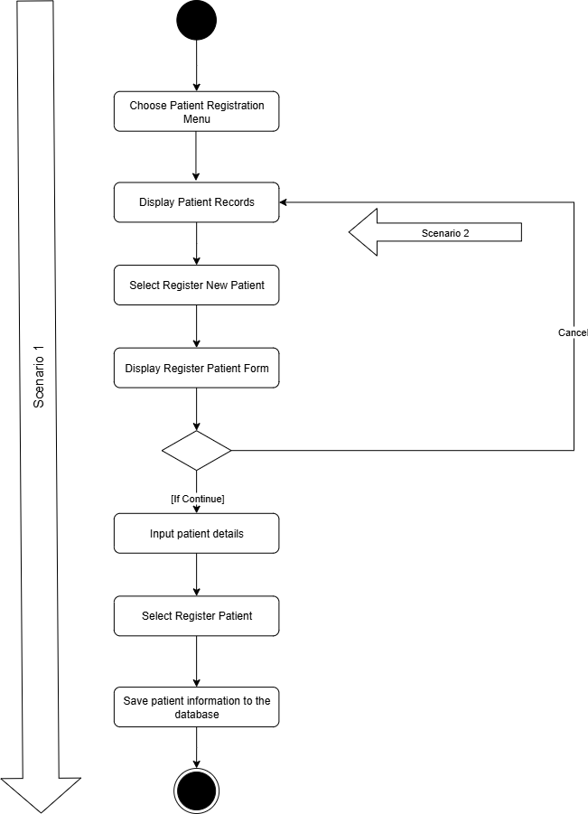

**Figure 6**

**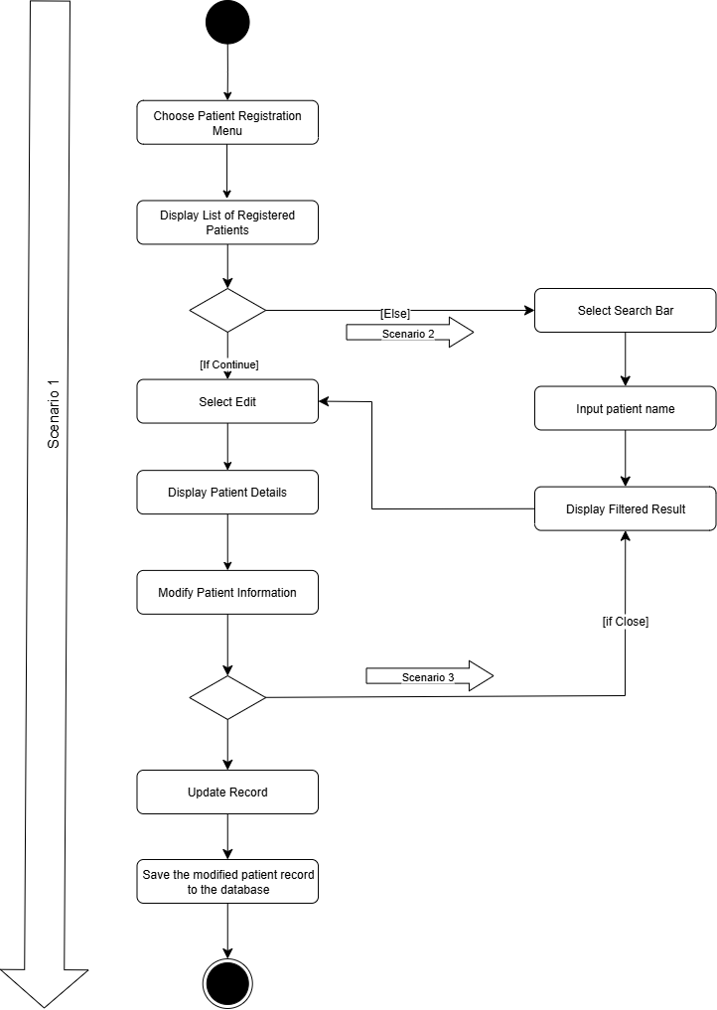***Activity Diagram for Update Patient Record*

**Figure 7**

***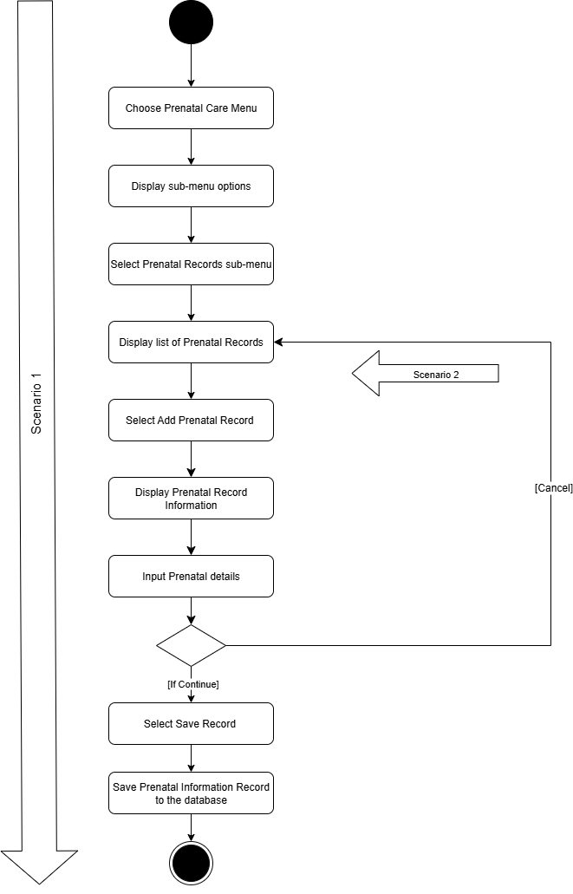****Activity Diagram for Add Prenatal Record*

**Figure 8**

*****Activity Diagram for Update Prenatal Record*

**Figure 9**

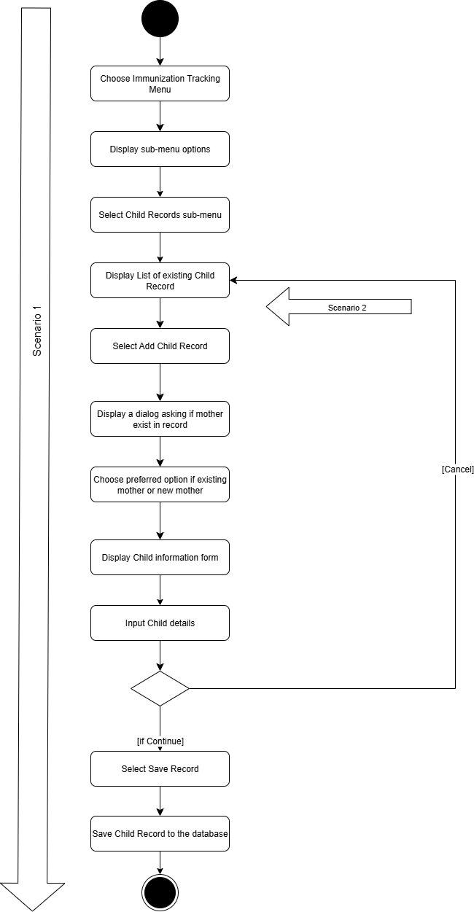*Activity Diagram for Add Child Record*

**Figure 10**

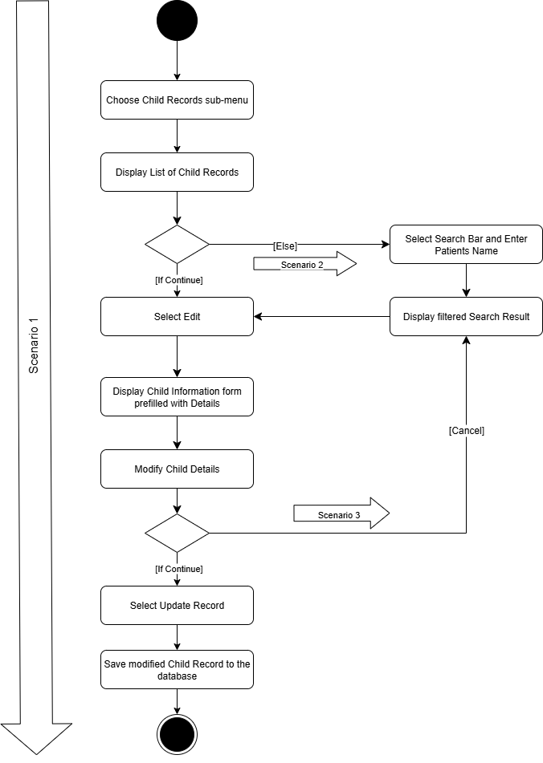*Activity Diagram for Update Child Record*

**Figure 11**

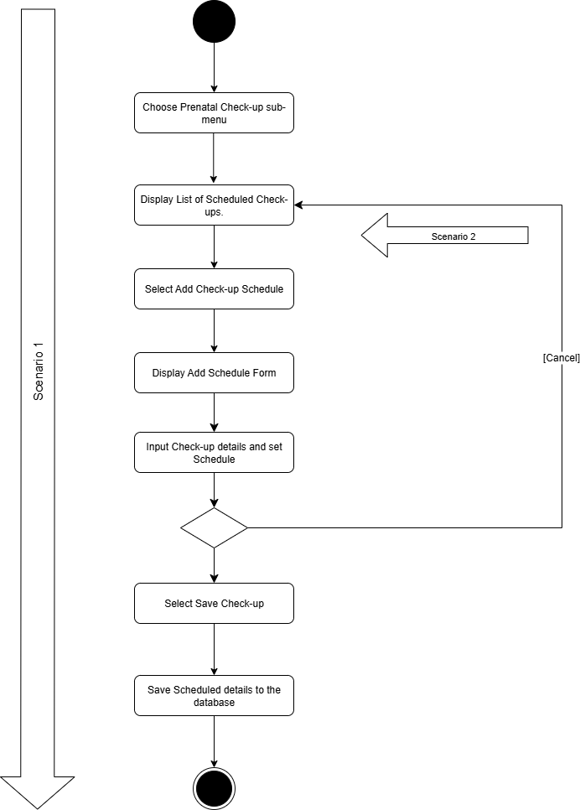Activity Diagram for Set Schedule for Prenatal Check-up

**Figure 12**

*Activity Diagram for Set Schedule for Immunization*

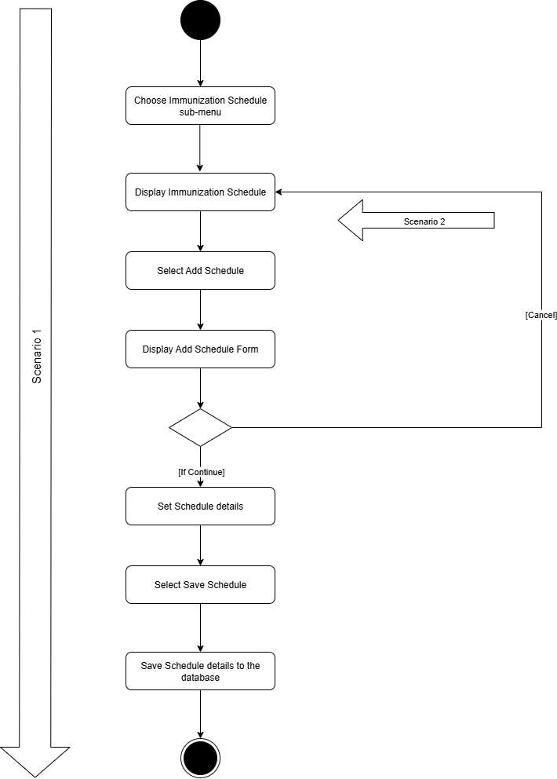

**Figure 13**

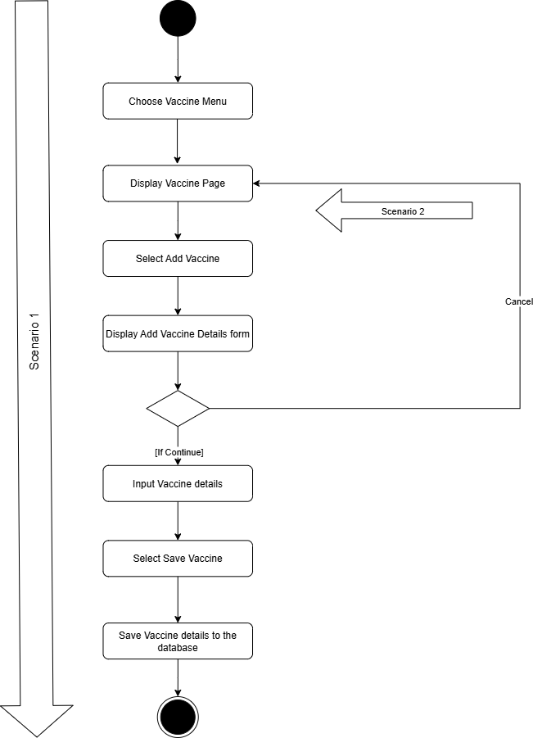*Activity Diagram for Add Vaccine*

**Figure 14**

*Activity Diagram for Create User Account*

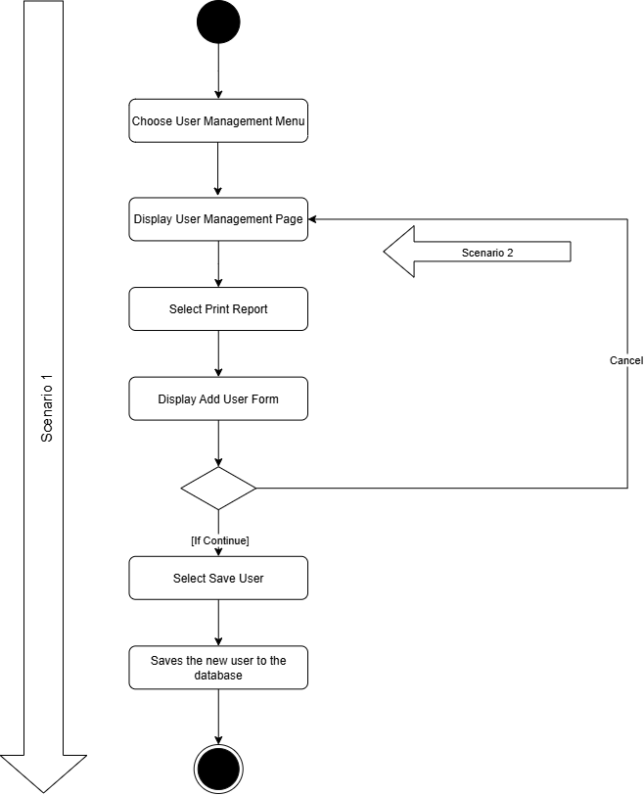

**Figure 15**

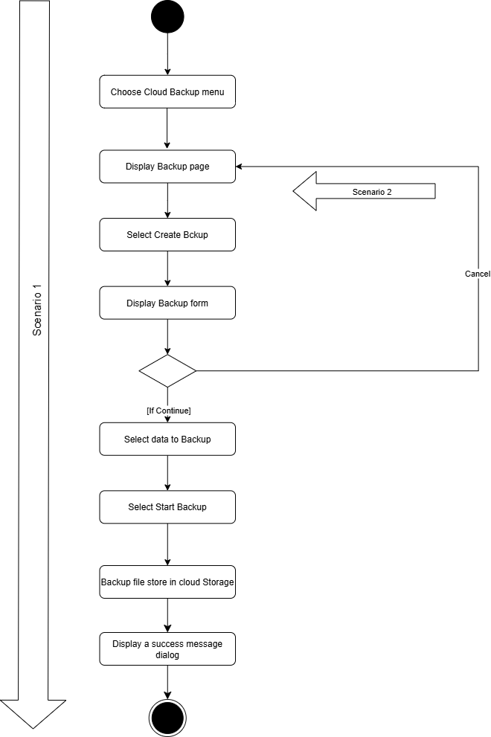*Activity Diagram for Perform Cloud Backup*

**Figure 16**

*Activity Diagram for Restore Database*

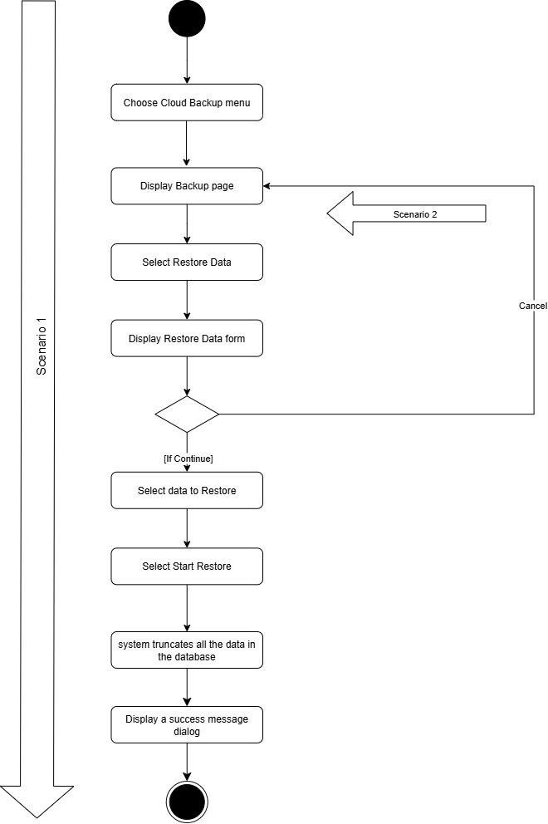

**Figure 17**

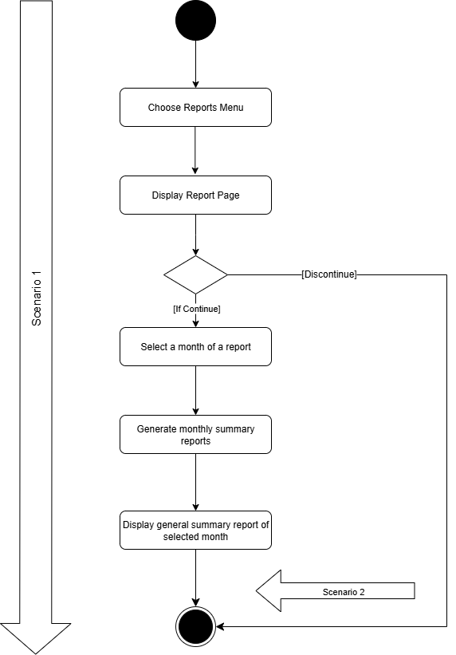*Activity Diagram for View Summary Report*

**Figure 18**

*Activity Diagram for Print Report*

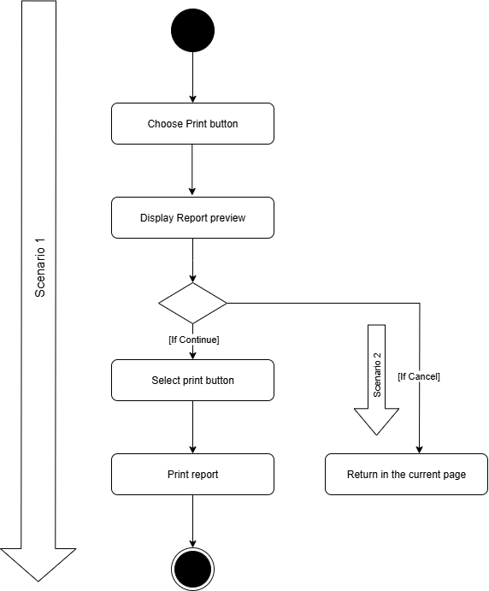

**3.5.1.4 Sequence Diagram**

**Figure 19**

*Sequence Diagram for Add New Patient*

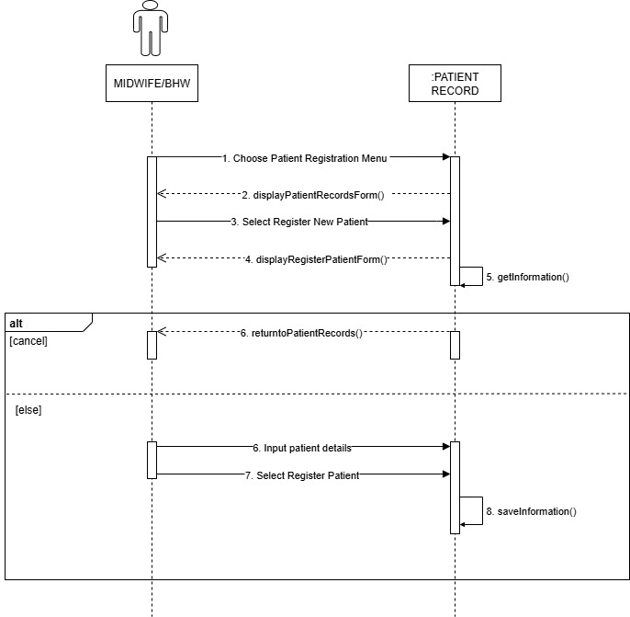

**Figure 20**

*Sequence Diagram for Update Patient Record*

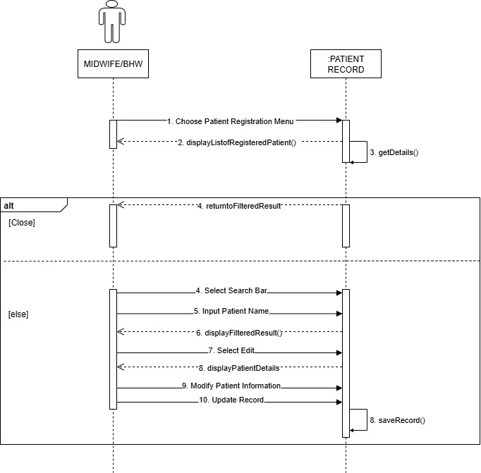

**Figure 21**

*Sequence Diagram for Add Prenatal Record*

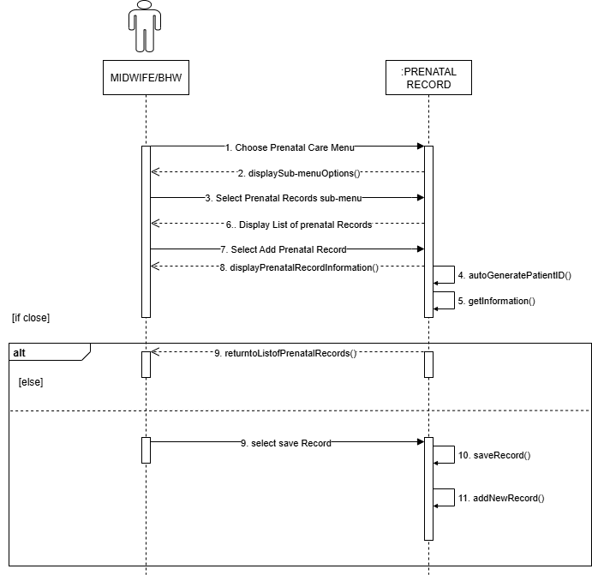

**Figure 22**

*Sequence Diagram for Update Prenatal Record*

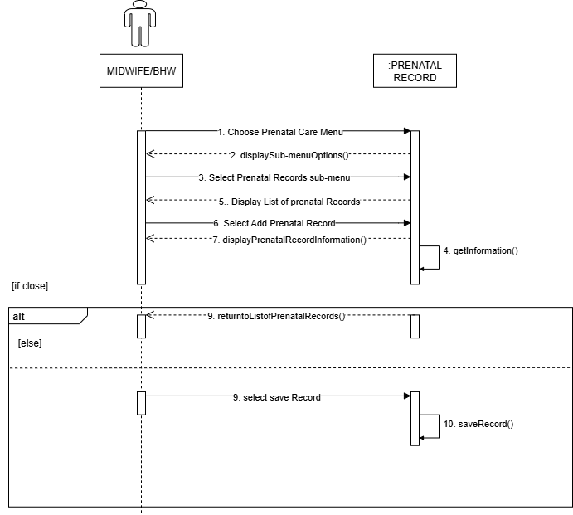

**Figure 23**

*Sequence Diagram for Add Child Record*

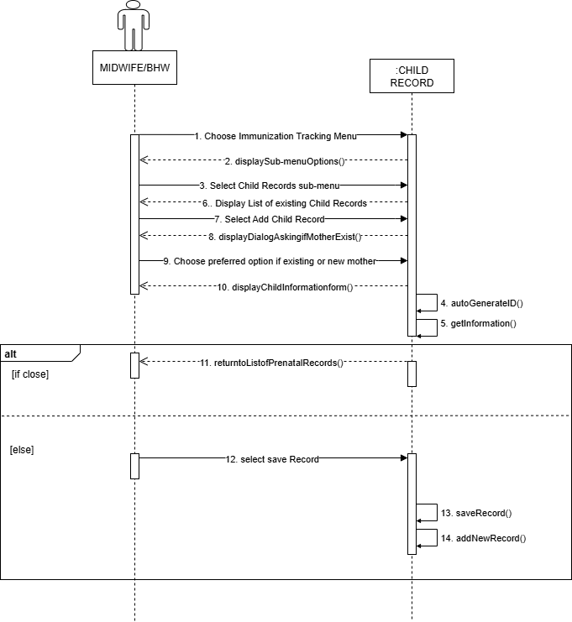

**Figure 24**

*Sequence Diagram for Update Child Record*

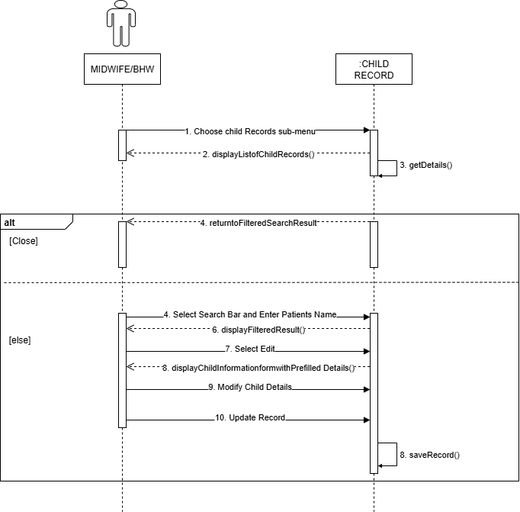

**Figure 25**

*Sequence Diagram for Set Schedule for Prenatal Check-up*

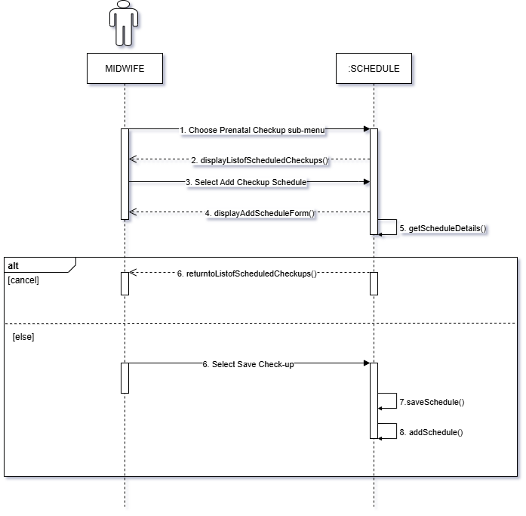

**Figure 26**

*Sequence Diagram for Set Schedule for Immunization*

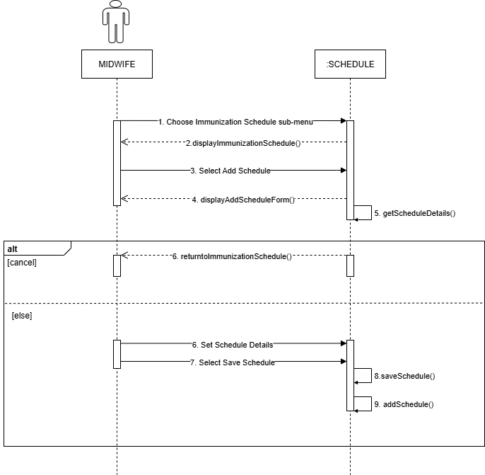

**Figure 27**

*Sequence Diagram for Add Vaccine*

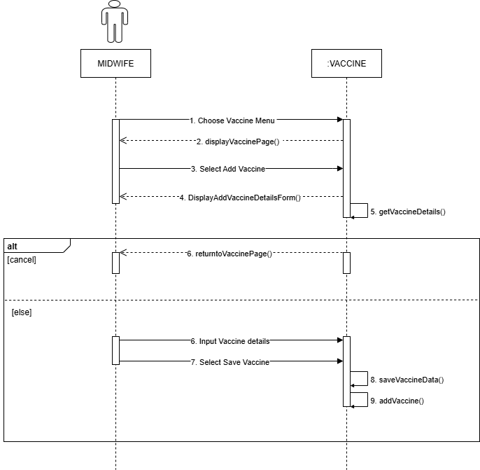

**Figure 28**

*Sequence Diagram for Create User Account*

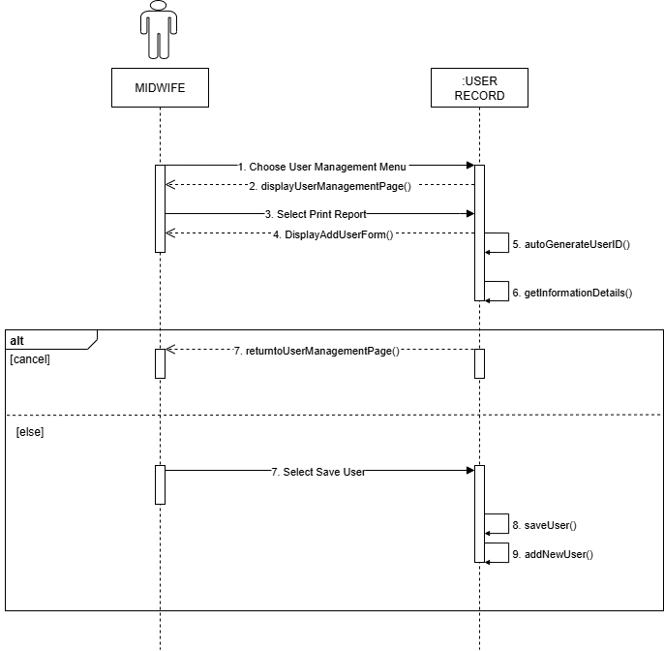

**Figure 29**

*Sequence Diagram for Perform Cloud Backup*

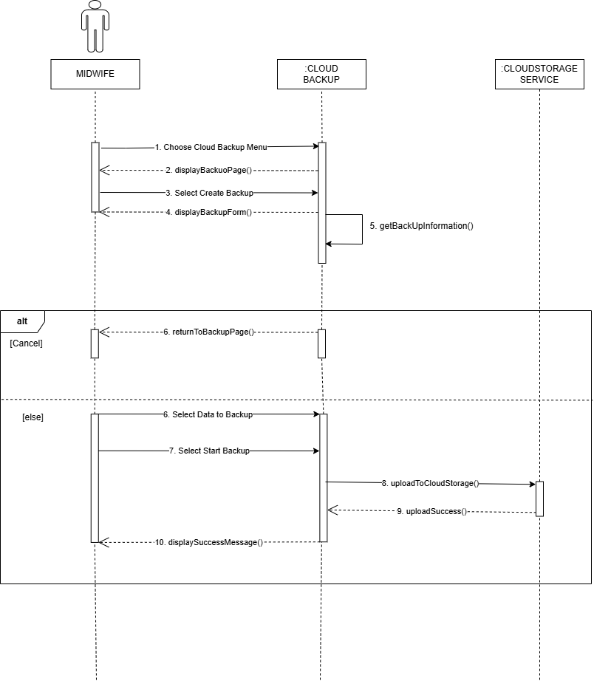

**Figure 30**

*Sequence Diagram for Restore Database*

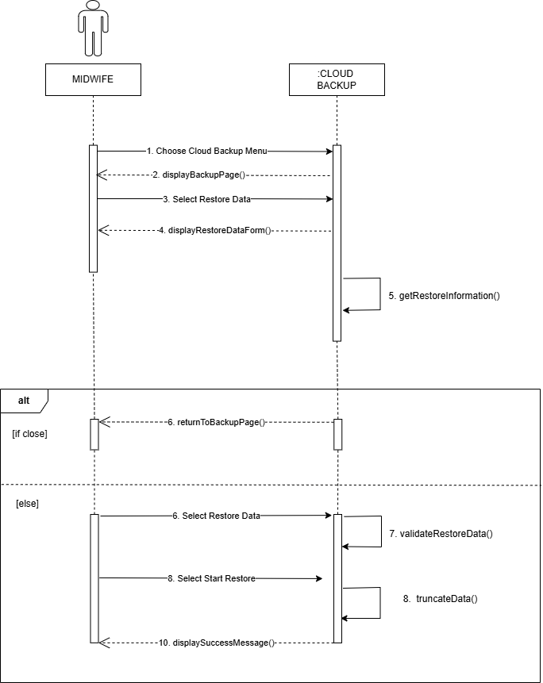

**Figure 31**

*Sequence Diagram for View Summary Report*

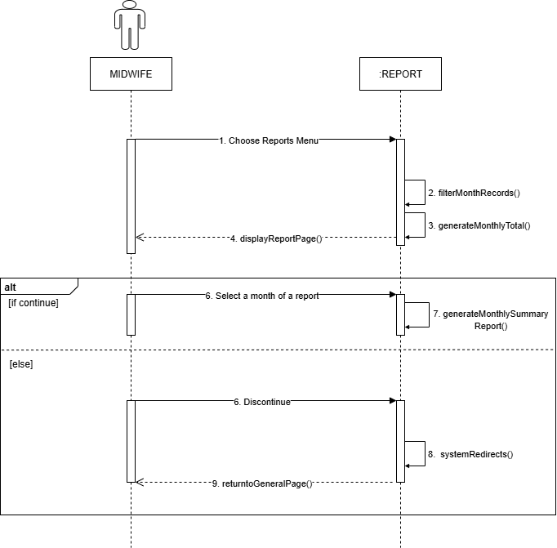

**Figure 32**

*Sequence Diagram for Print Report*

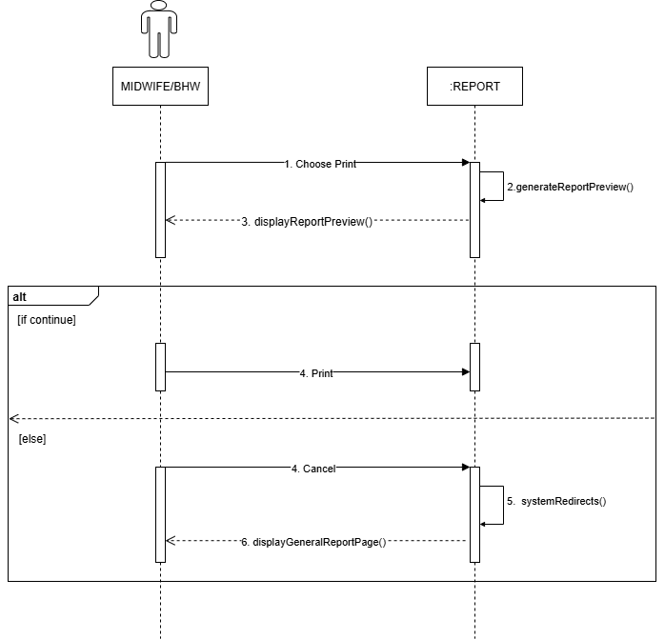

**3.5.1.5 Communication Diagram**

**Figure 33**

*Communication Diagram for Add New Patient*

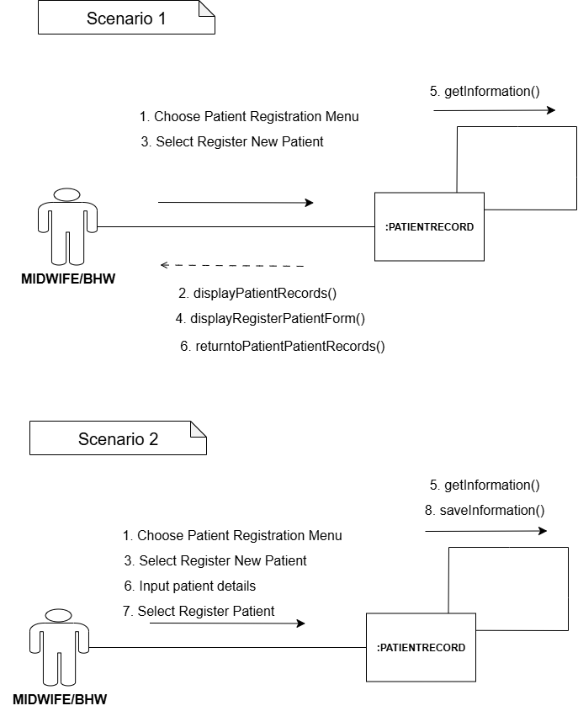

**Figure 34**

*Communication Diagram for Update Patient Record*

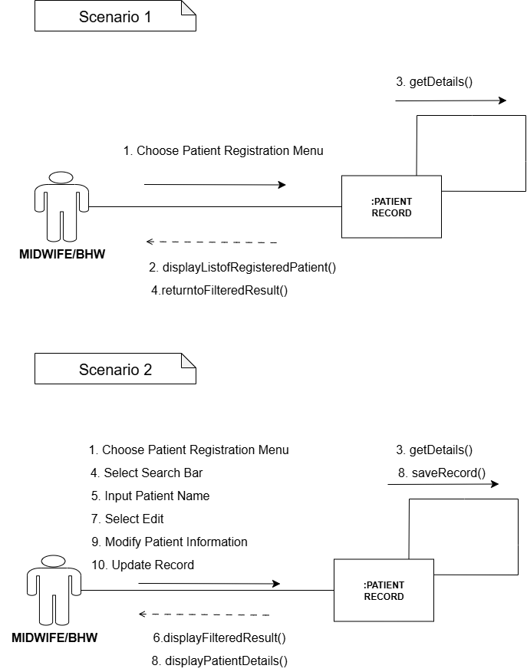

**Figure 35**

*Communication Diagram for Add Prenatal Record*

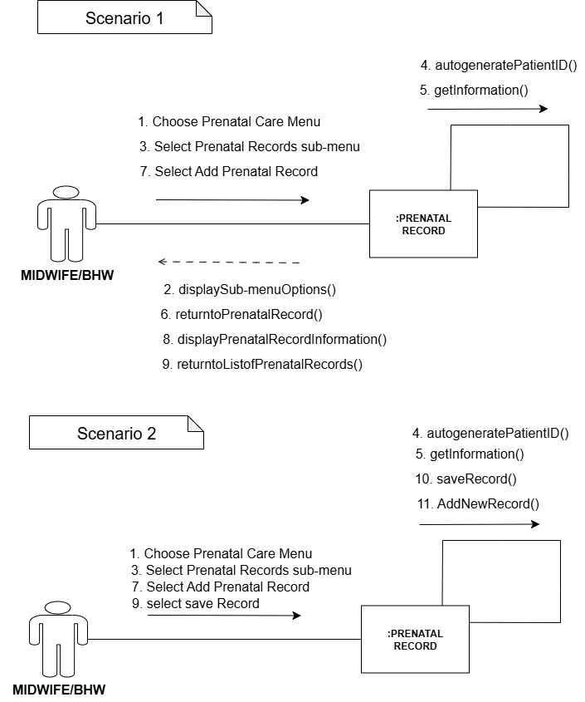

**Figure 36**

*Communication Diagram for Update Prenatal Record*

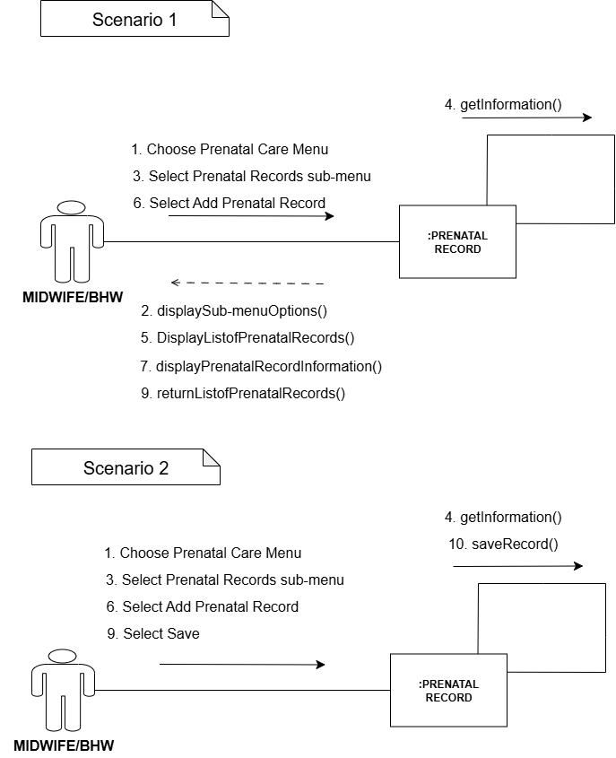

**Figure 37**

*Communication Diagram for Add Child Record*

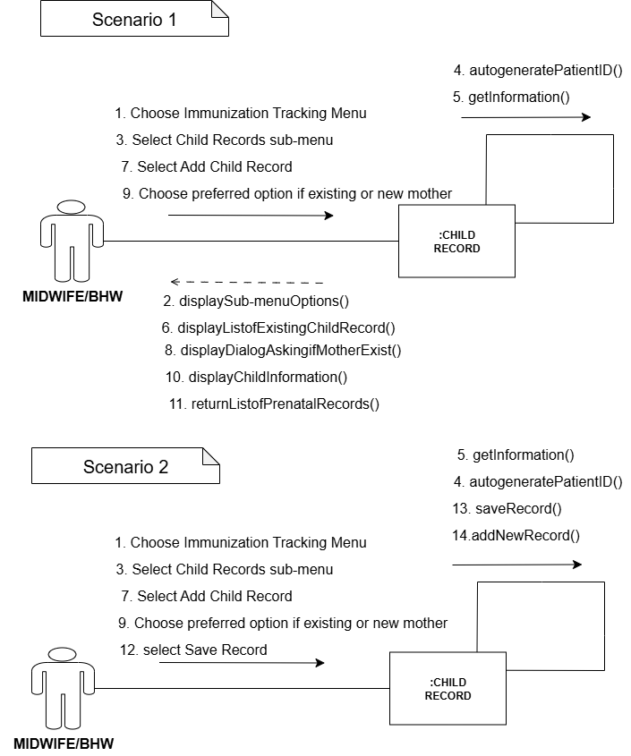

**Figure 38**

*Communication Diagram for Update Child Record*

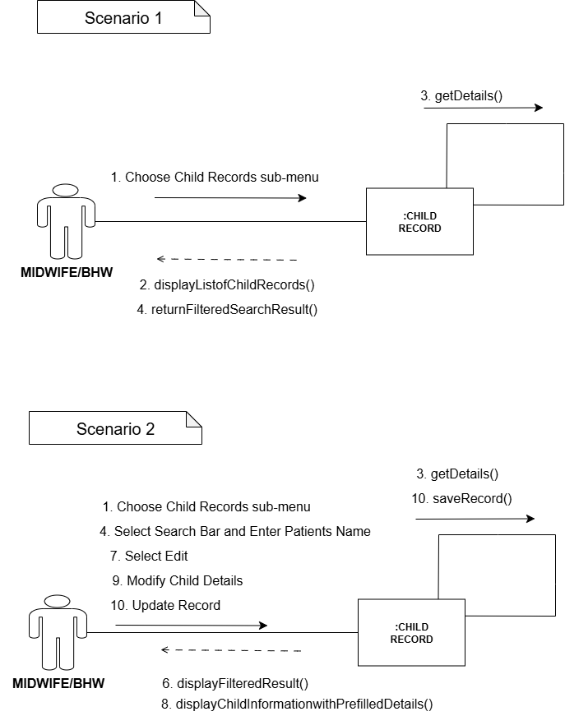

**Figure 39**

*Communication Diagram for Set Schedule for Prenatal Check-up*

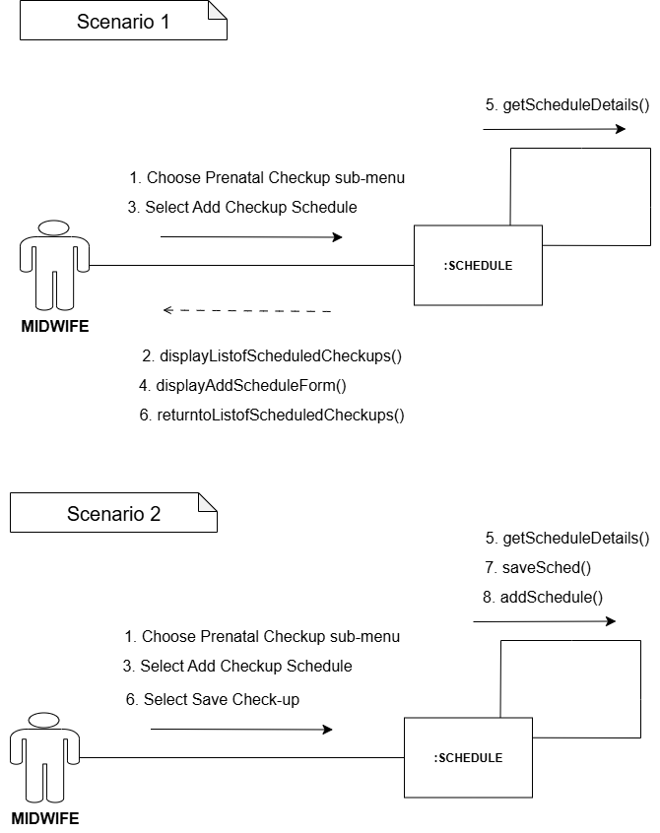

**Figure 40**

*Communication Diagram for Set Schedule for Immunization*

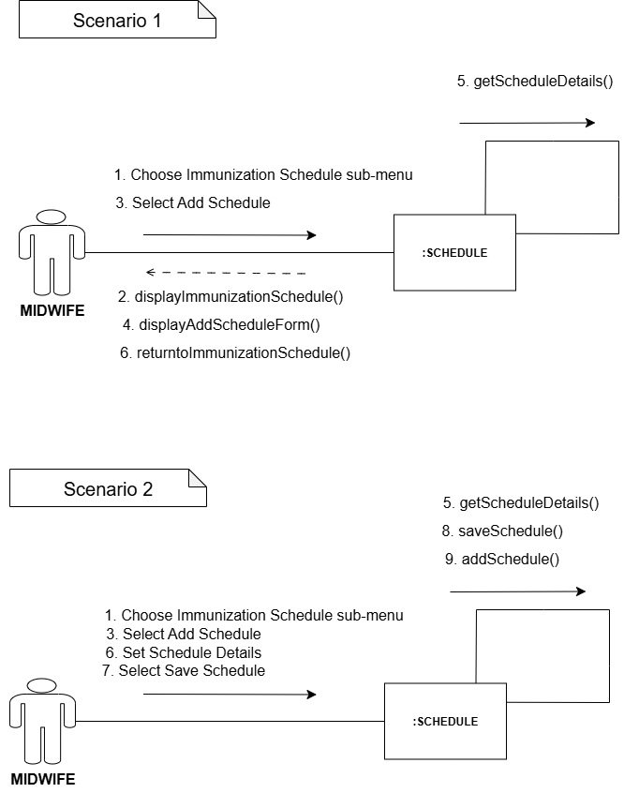

**Figure 41**

*Communication Diagram for Add Vaccine*

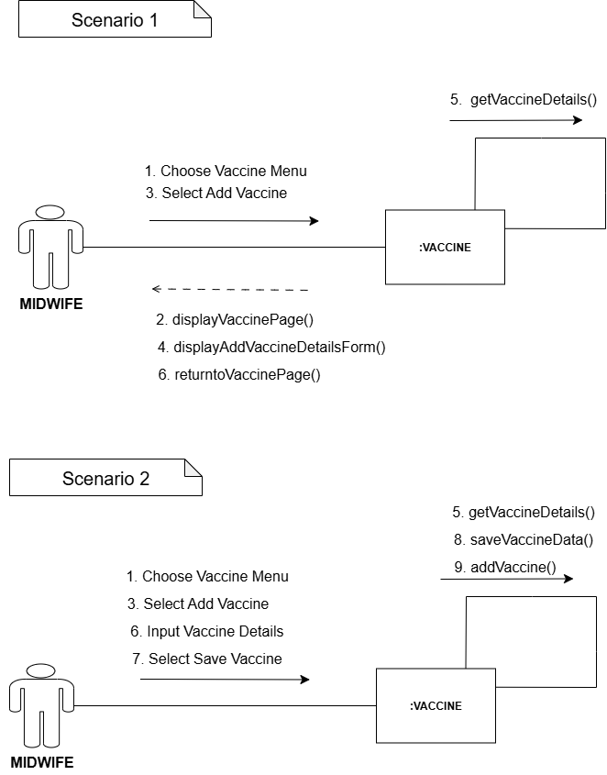

**Figure 42**

*Communication Diagram for Create User Account*

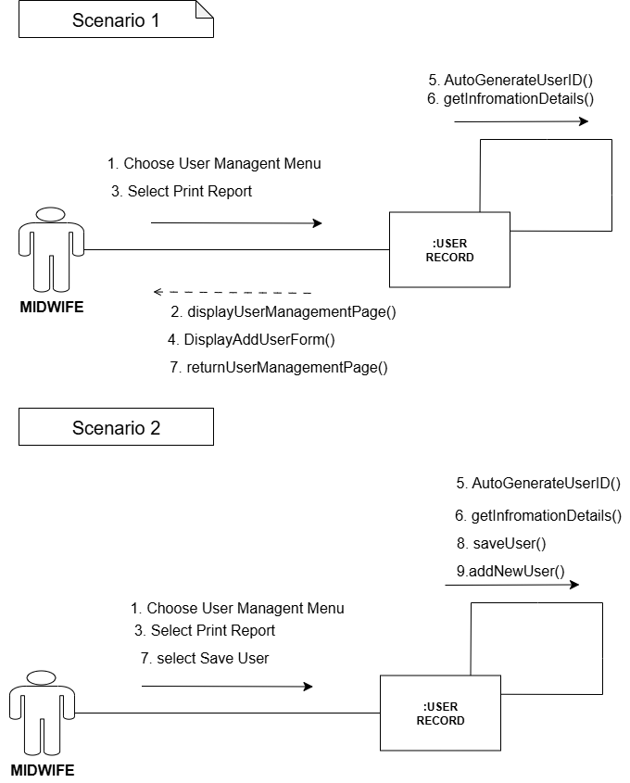

**Figure 43**

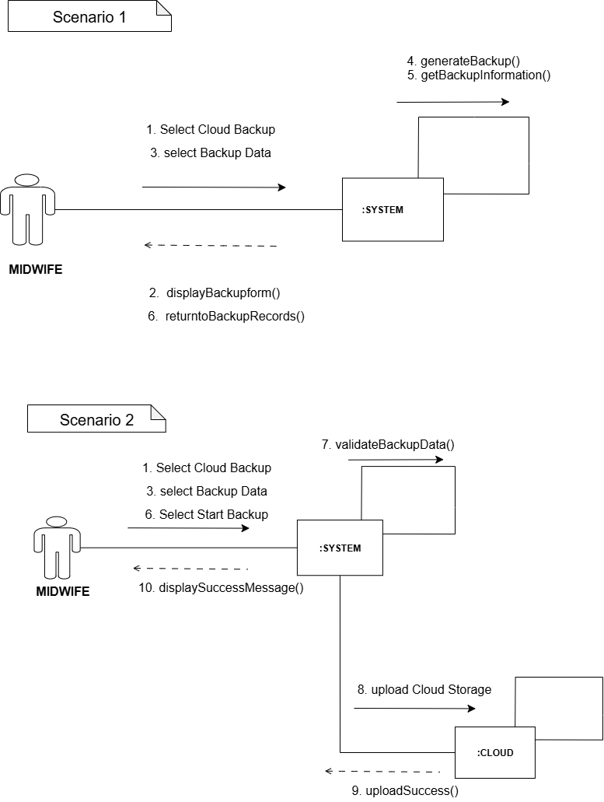*Communication Diagram for Perform Cloud Backup*

**Figure 44**

*Communication Diagram for Restore Database*

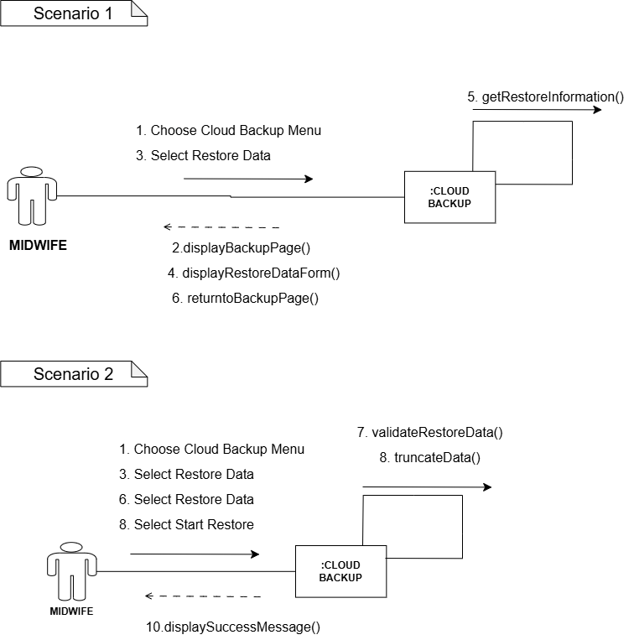

**Figure 45**

*Communication Diagram for View Summary Report*

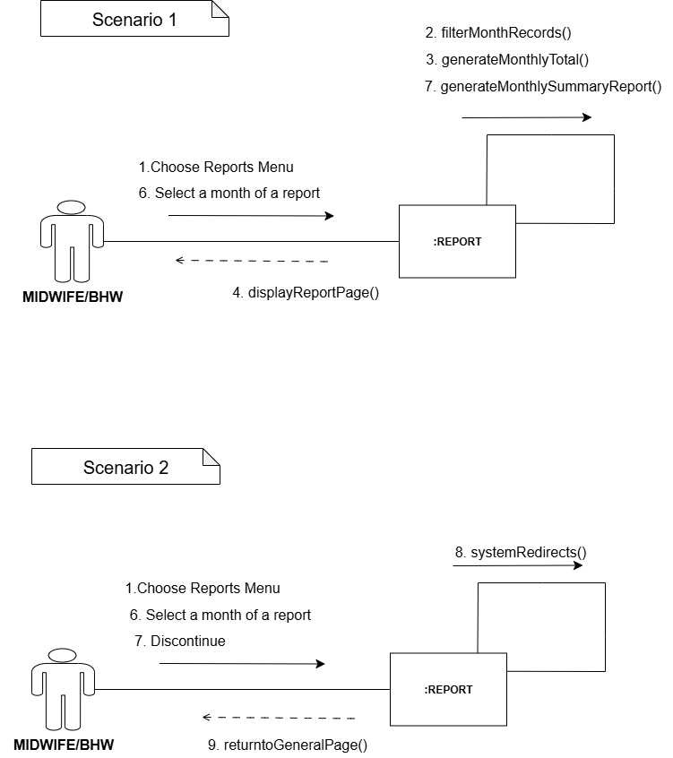

**Figure 46**

*Communication Diagram for Print Report*

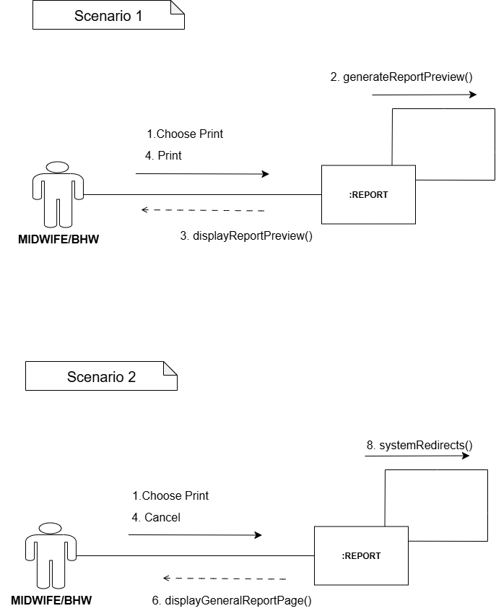

**3.5.2 Structural Diagrams**

**3.5.2.1 Class Diagram**

**Figure 57**

*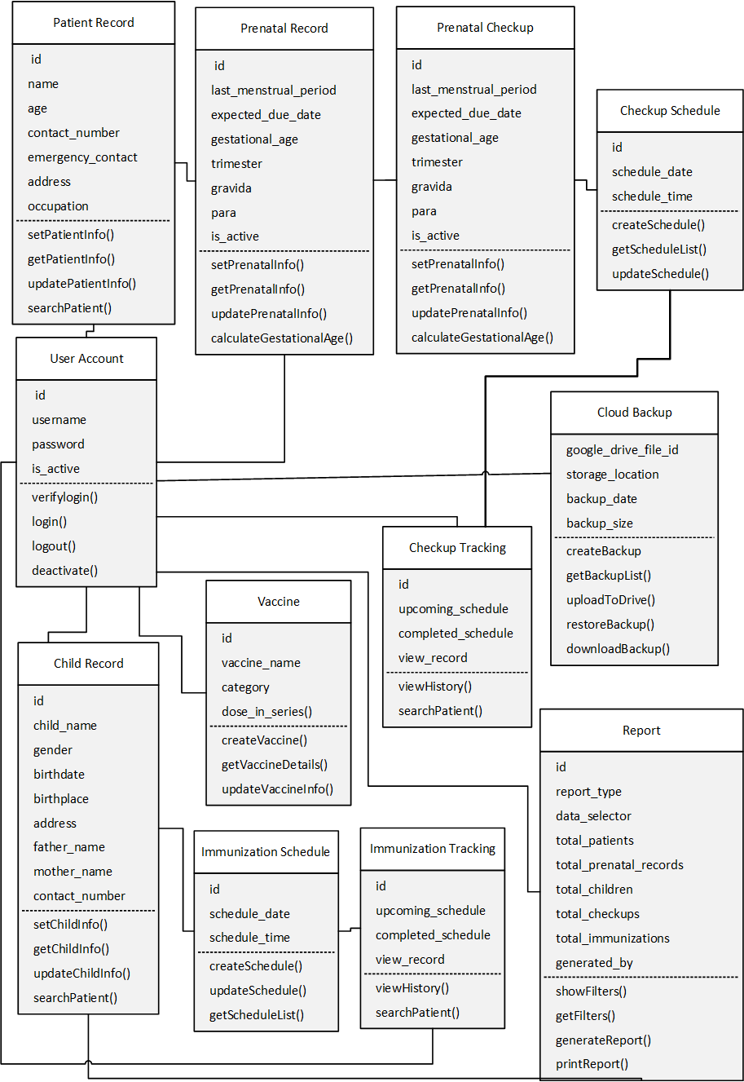Class diagram for A Web-based System for Prenatal and Immunization Records in Dumalinao, Zamboanga del Sur.*

**3.5.2.1 Package Diagram**

**Figure 58**

*Package diagram for A Web-based System for Prenatal and Immunization Records in Dumalinao, Zamboanga del Sur.*

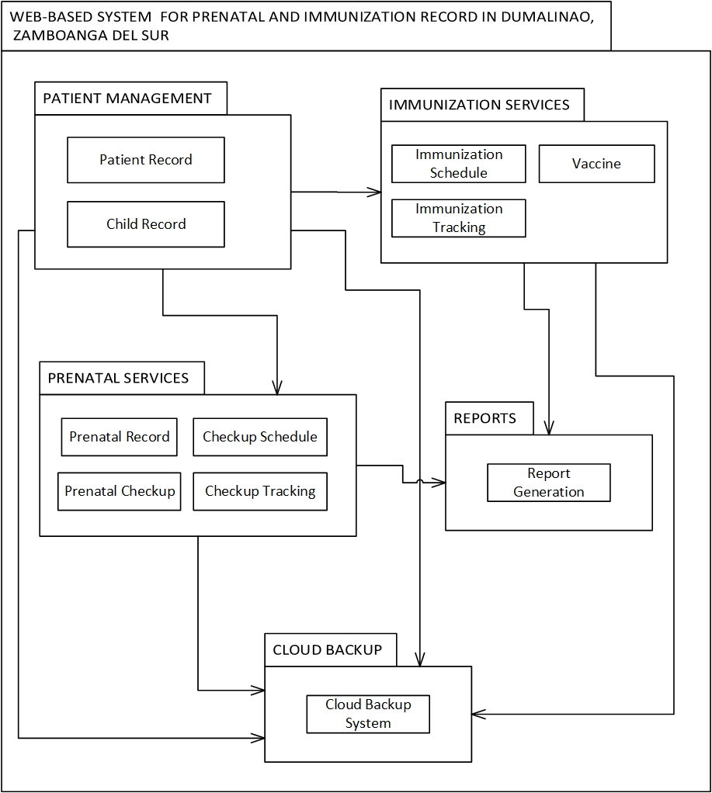

**3.6 Coding**

In this phase of the software development process, the proponents turned the designs and diagrams into the actual system. They wrote the code and built the features using PHP and MySQL, showing how the system stores information, delivers records, and interacts with users. This stage typically takes the most time, as it serves as the foundation for the entire project. The developers carefully developed each part of the design into a working feature until the system was complete. Documentation was kept at every step, serving as a reference for the team and future researchers. After the developers developed the system, the researchers held a presentation to review the results and confirm that the functions matched the requirements. During this review, the team also discussed potential limitations that may arise in the next testing phase to inform improvements.

**3.6.1 User Interfaces**

**Figure 47**

***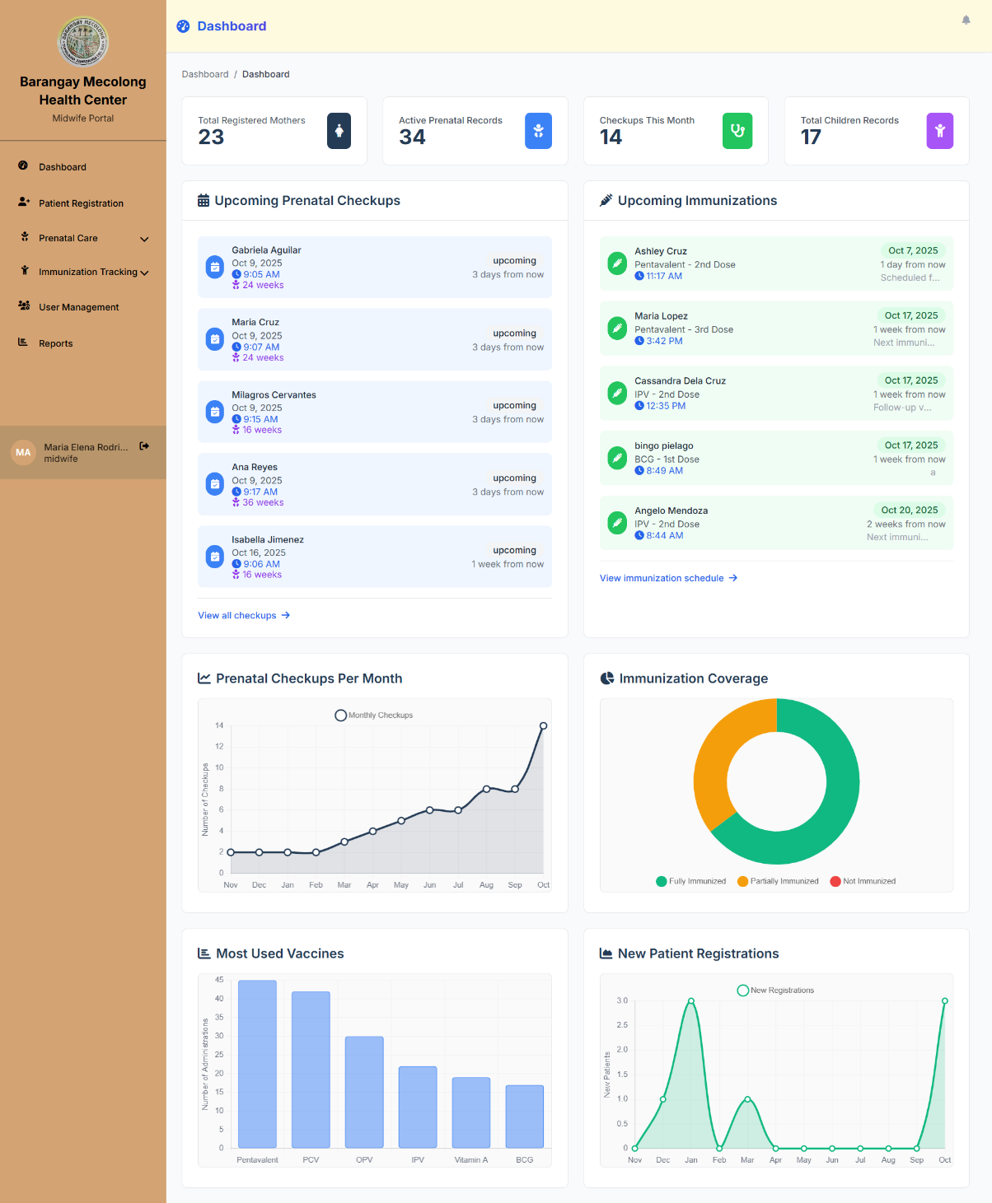****Use Interface for Dashboard*

**Description:** A midwife portal dashboard that tracks mothers, prenatal records, checkups, and children. A healthcare worker can see the total registered mothers, active prenatal records, monthly checkups, and total children records. The dashboard shows charts for prenatal checkups per month, immunization coverage, most used vaccines, and new patient registrations.

**Pseudocode:** Start

If the User is in the Midwife role

Display Midwife Portal Dashboard

Load Total Registered Mothers

Load Active Prenatal Records

Load Checkups This Month

Load Total Children Records

Load Prenatal Checkups Per Month chart

Load the Immunization Coverage chart

Load Most Used Vaccines chart

Load the New Patient Registrations chart

Else

Remove Dashboard access

Redirect to another page

End If

**Figure 48**

*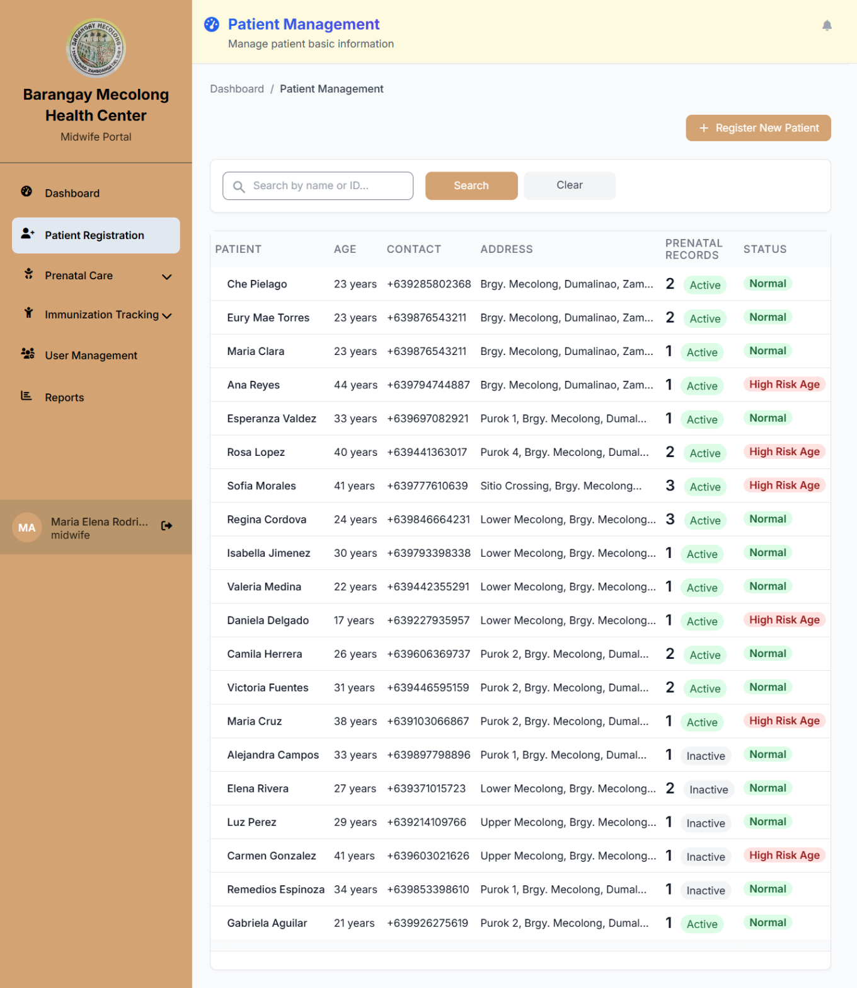User Interface for Patient Registration*

**Description**: In this figure, the Patient Registration page allows the midwife to view patient basic information on a single page, including a List of Patients with the following fields: Patient ID, Patient Name, Age, Contact, Address, Prenatal Records, and Status. In addition, this page allows a midwife to perform the following actions: Register New Patient, View Patient Information, and Edit Patient Details. The following actions allows the midwife to view and monitor patient records and information of a patient's basic information. As well as, allowing the midwife to update a patient's record of information.

**Pseudocode:** Start

If the User is in the Midwife role

Display Patient Registration page

Show patient list table

Show Register New Patient button

Show view and edit actions

Else

Remove Patient Registration from Navigation Bar

End If

**Figure 49**

*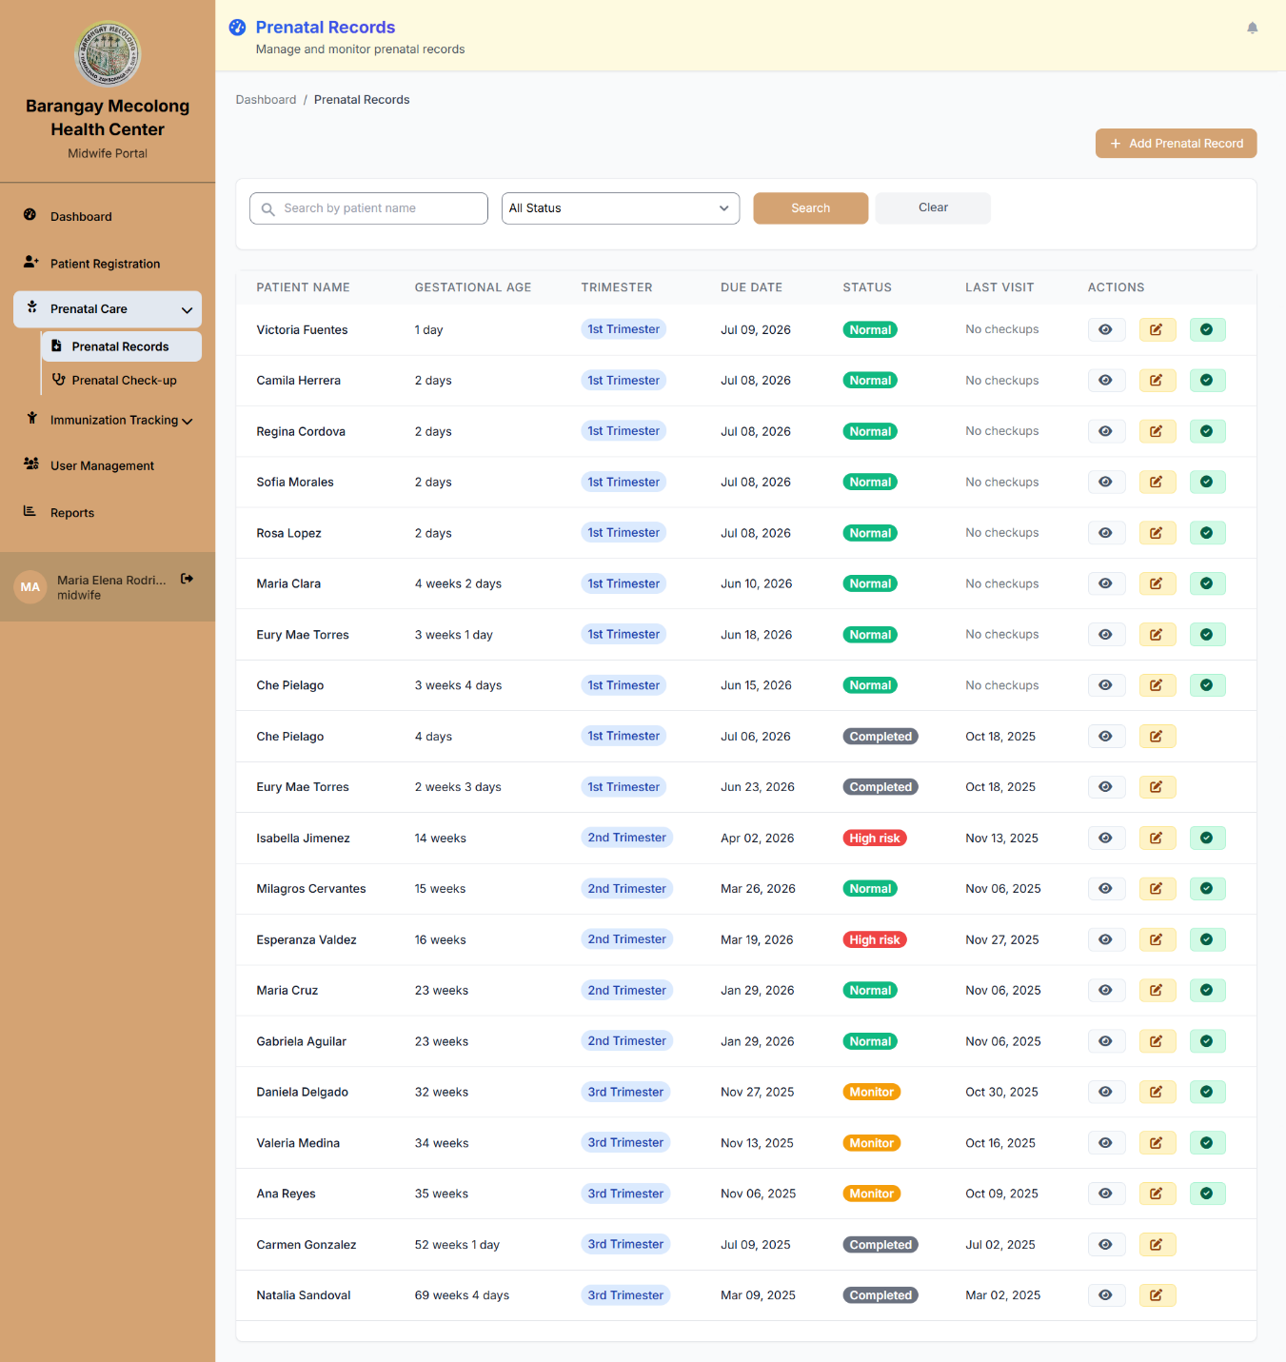User Interface for Prenatal Records*

**Description:** In this figure, the Prenatal Records page allows the midwife to manage and monitor prenatal records in one page, consisting of a List of Prenatal Records with the following: Record ID, Patient ID, Patient Name, Gestational Age, Trimester, Due Date, Status, and Last Visit. In addition, this page allows a midwife to perform the following actions: Add Prenatal Record, View Prenatal Information, and Edit Prenatal Details. The following actions allow the midwife to view and monitor the prenatal check-up history and information in a prenatal record. As well as allowing the midwife to update a prenatal record.

**Pseudocode**: Start

If the User is in the Midwife role

Display Prenatal Records page

Show the prenatal records table

Show Add Prenatal Record button

Show view and edit actions

Else

Remove Prenatal Records from Navigation Bar

End If

**Figure 50**

*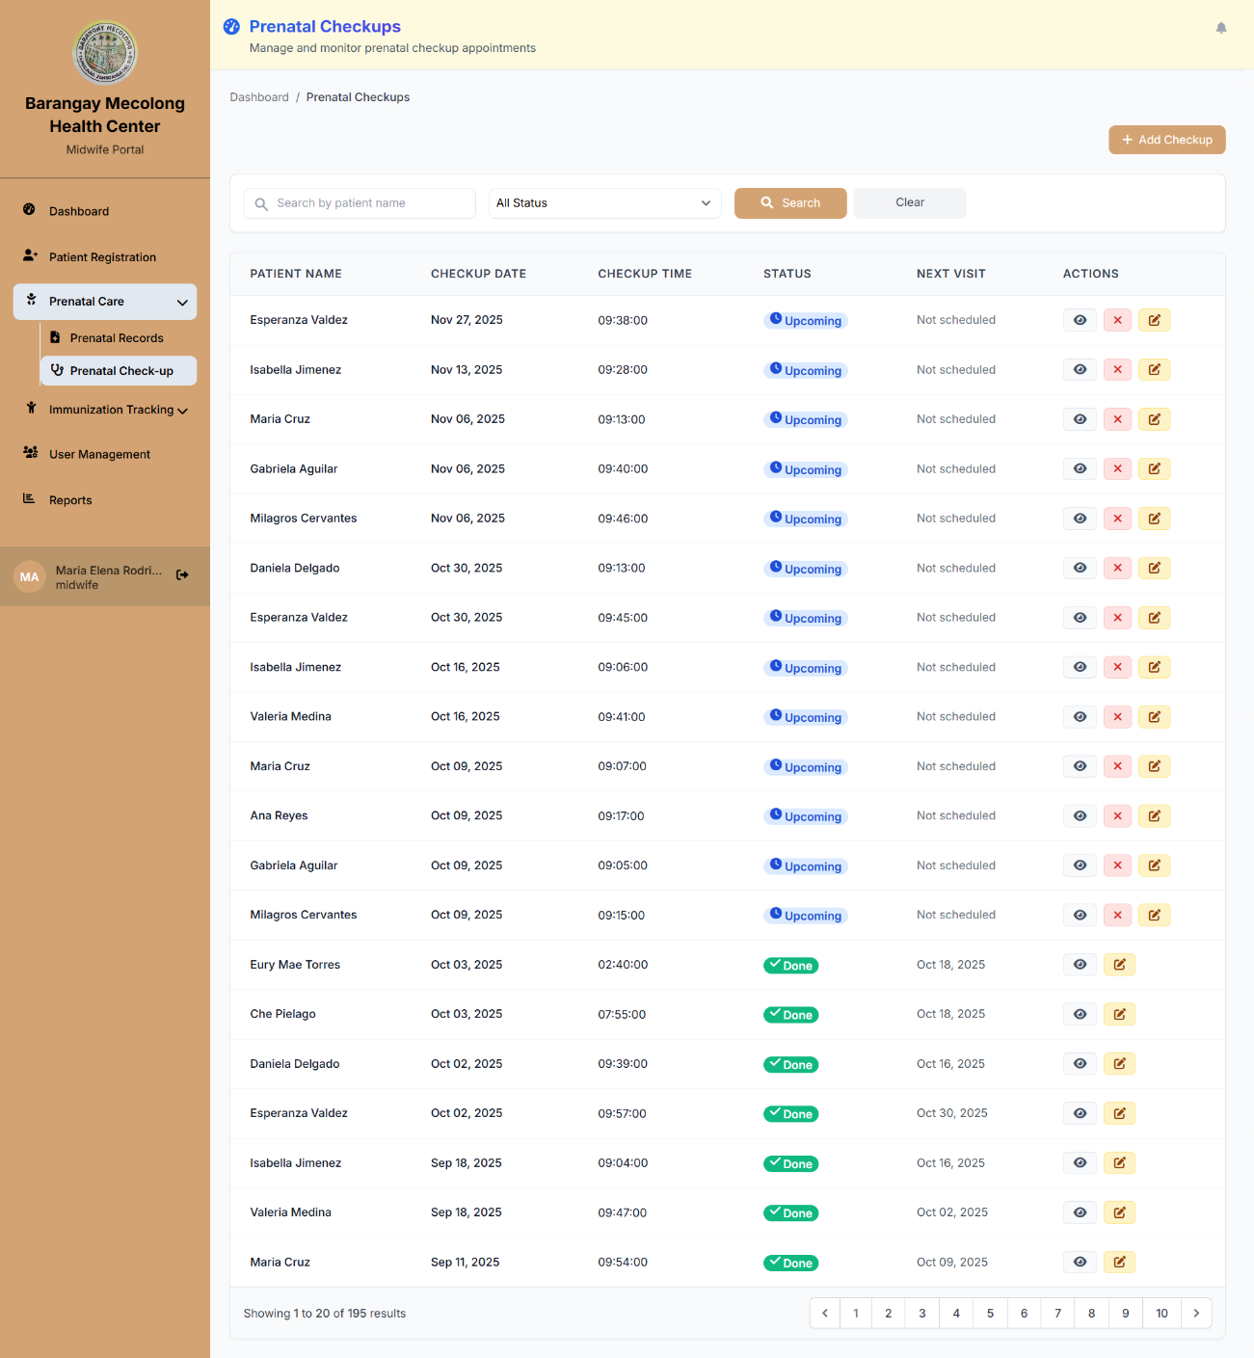User Interface for Prenatal Check-ups*

**Description**: The Prenatal Check-up page allows the midwife to track prenatal appointments and visits in one page, consisting of a List of Prenatal Check-ups with the following: Record ID, Patient ID, Patient Name, Gestational Age, Trimester, Due Date, Status, and Last Visit. In addition, this page allows a midwife to perform the following actions: Add Prenatal Record, View Check-up Information, and Monitor Patient Status. The following actions allows the midwife to view the information of a prenatal check-up record. As well as allowing the midwife to update a check-up record of information.

**Pseudocode:** Start

If the User is in the Midwife role

Display Prenatal Check-up page

Show the check-up records table

Show Add Prenatal Record button

Show view and monitor actions

Else

Remove Prenatal Check-up from Navigation Bar

End If

**Figure 51**

*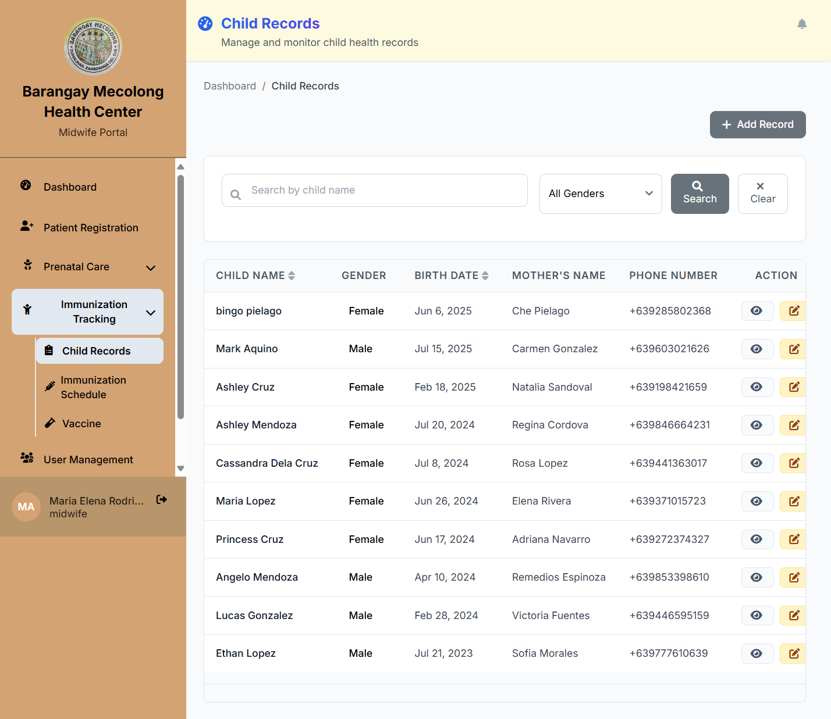User Interface for Child Records*

**Description**: The Child Records page allows the midwife to manage and monitor child health records on a single page, featuring a List of Children with the following fields: Child ID, Child Name, Gender, Birth Date, Mother's Name, Phone Number, and Action. In addition, this page allows a midwife to perform the following actions: Add Record, View Child Information, and Edit Child Details. The following actions will enable the midwife to track child health information. As well as allowing the midwife to update child health records and monitor immunization history.

**Pseudocode**: Start

If the User is in the Midwife role

Display Child Records page

Show child records table

Show Add Record button

Show child management actions

Else

Remove Child Records from Navigation Bar

End If

**Figure 52**

***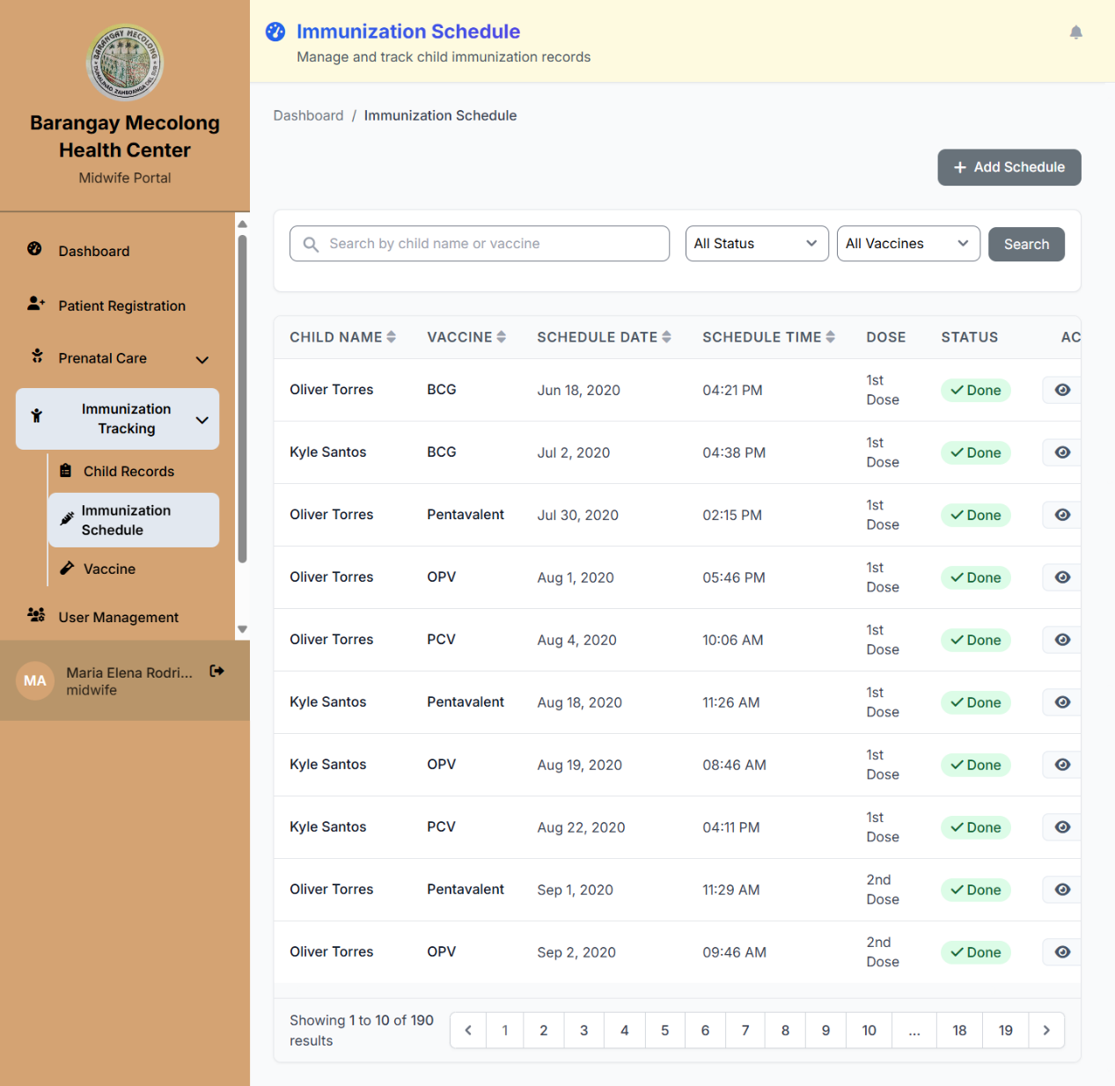****User Interface of Immunization*

**Description:** The Immunization Schedule page allows the midwife to manage child immunization records on a single page, with a List of Immunization Schedules that includes: Immunization ID, Child Name, Vaccine, Schedule Date, Schedule Time, Dose, Status, and Action. In addition, this page allows a midwife to perform the following actions: Add Schedule, View Schedule Information, and Edit Schedule Details. As well as allowing the midwife to update immunization records.

**Pseudocode**: Start

If the User is in the Midwife role

Display Immunization Schedule page

Show immunization schedule table

Show Add Schedule button

Show schedule management actions

Else

Remove Immunization Schedule from Navigation Bar

End If

**Figure 53**

*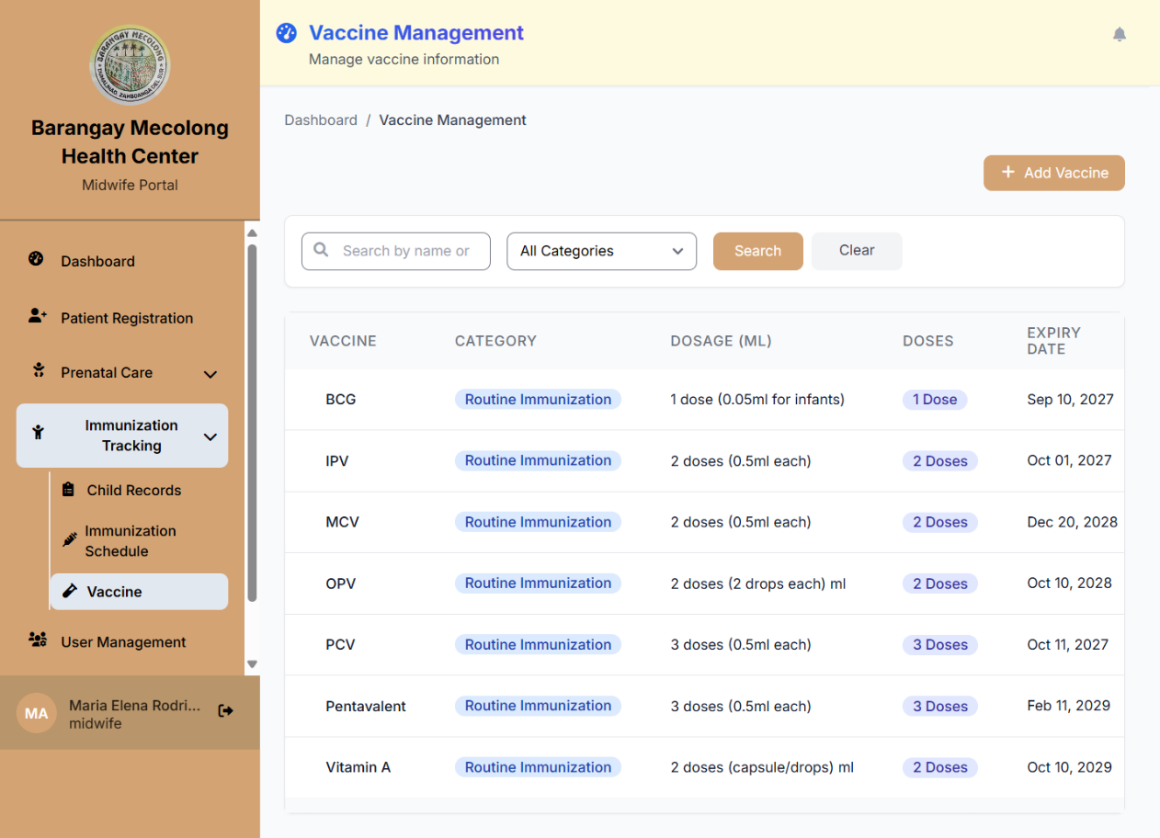User Interface for Vaccine*

**Description**: The Vaccine page allows the midwife to manage vaccine information on one page, consisting of a List of Vaccines with the following: Vaccine, Category, Dose, Doses, Expiry Date, and Actions. In addition, this page allows a midwife to perform the following actions: add a Vaccine, View Vaccine Information, and Edit Vaccine Details. These actions allow the midwife to update vaccine records.

**Pseudocode**: Start

Pseudocode: Start

If the User is in the Midwife role

Show Vaccine Management page

Show vaccine list

Show search options

Show vaccine table

Show Add Vaccine button

Show actions for viewing and editing

Else

Redirect to Login

End If

**Figure 54**

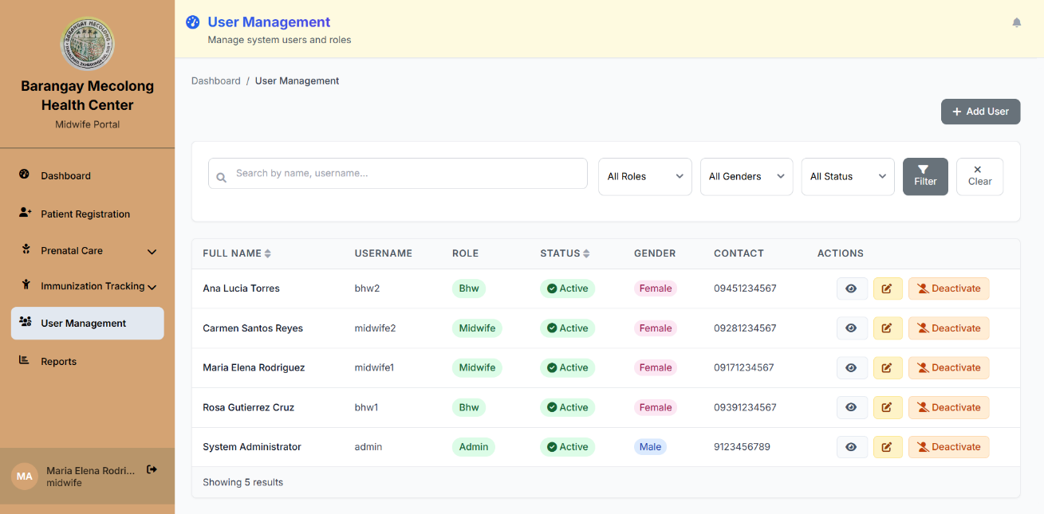*User Interface for User Management*

**Description**: The User Management page allows the midwife to manage system users and roles on a single page, with a List of Users that includes: Full Name, Username, Role, Status, Gender, Contact, and Actions. In addition, this page allows a midwife to perform the following actions: Add User, View User Information, Edit User Details, and Deactivate User. The following actions enable the midwife to manage user accounts and system access. Additionally, it allows the midwife to update user information and control user permissions.

**Pseudocode**: Start

If the User is in the Midwife role

Display the User Management page

Show user list table

Show Add User button

Show user management actions

Else

Remove User Management from the Navigation Bar

End If

**Figure 55**

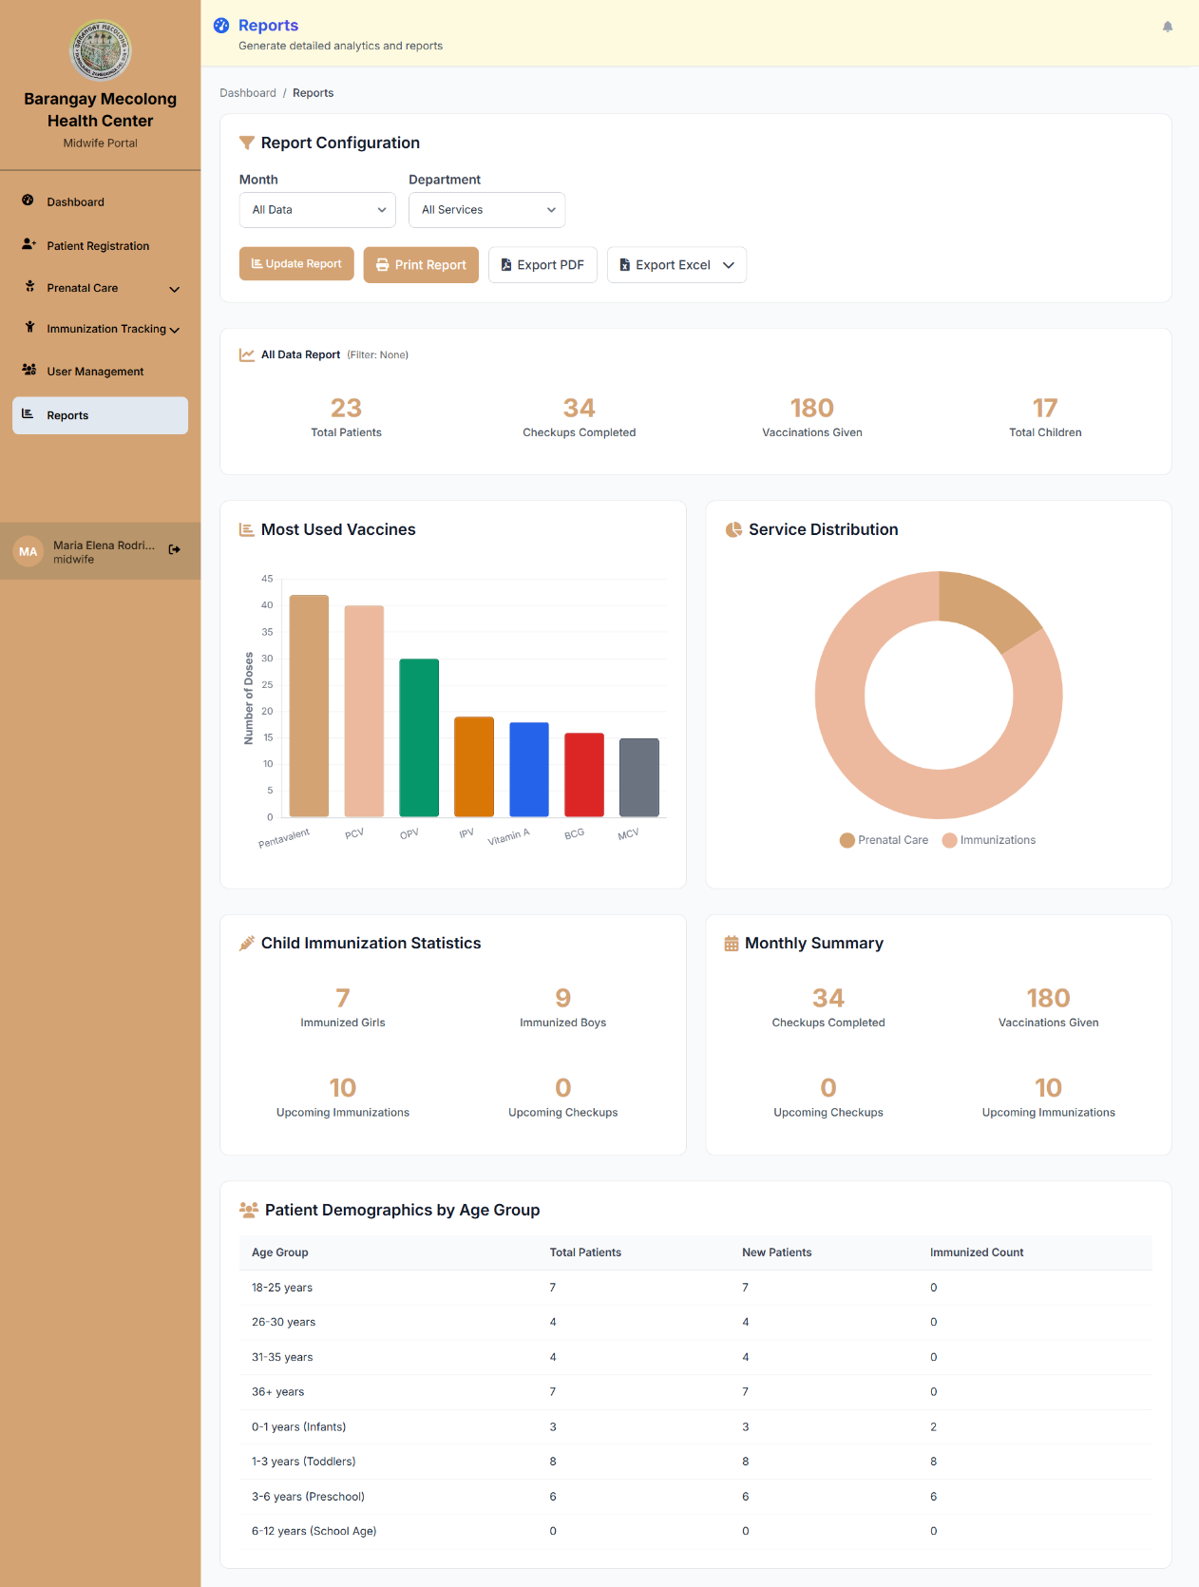*User Interface for Report*

**Description**: The Reports page allows the midwife to generate detailed analytics and reports on one page, consisting of summary metrics with the following: Total Patients, Checkups Completed, Vaccinations Given, and Total Children. In addition, this page allows a midwife to view analytics, including the Most Used Vaccines chart, the Service Distribution chart, Child Immunization Statistics, and the Monthly Summary. The following analytics allow the midwife to monitor and track healthcare data and vaccination records and print reports for healthcare management.

**Pseudocode:** Start

If the User is in the Midwife role

Display Reports page

Show summary metrics

Show analytics charts

Show statistics data

Else

Remove Reports from Navigation Bar

End If

**Figure 56**

*User Interface for Cloud Backup*

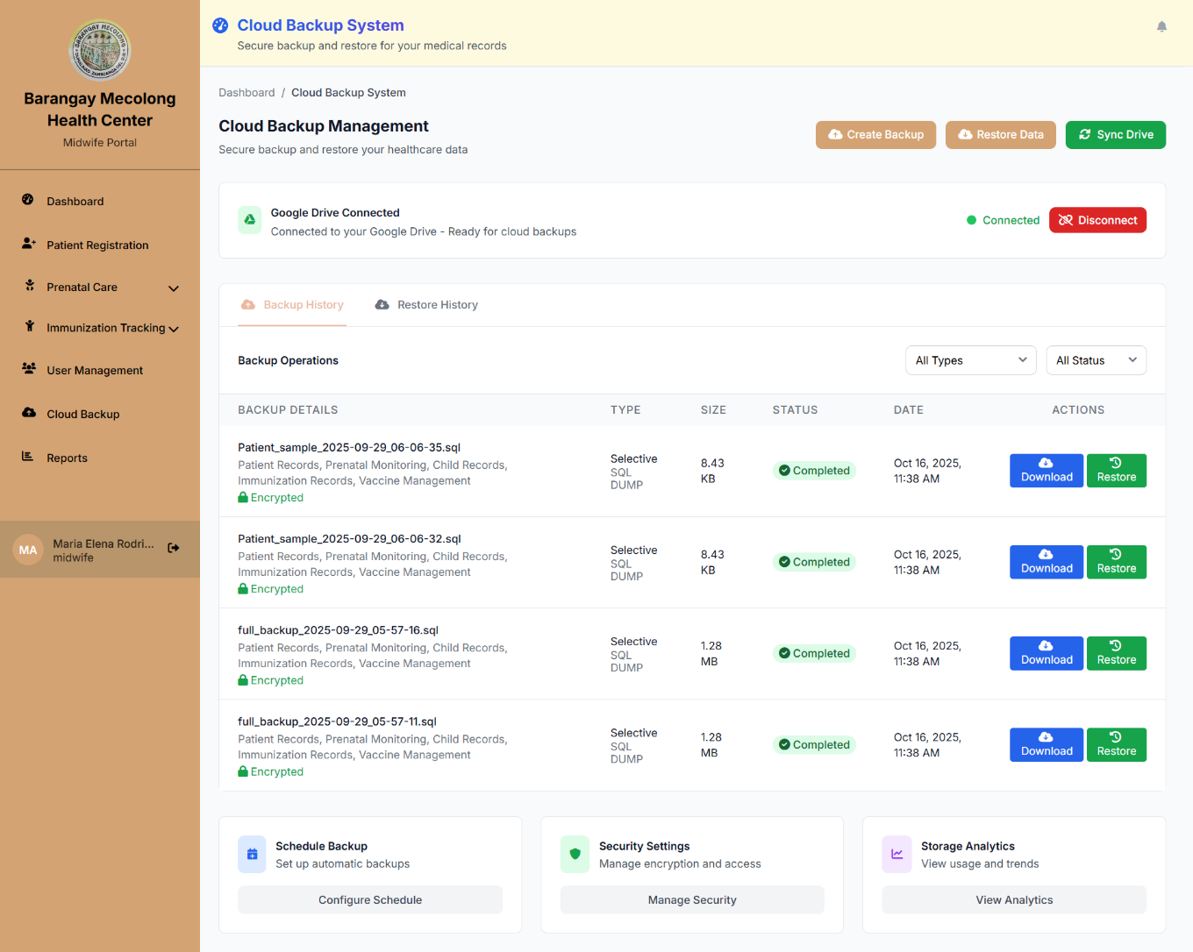

**Description**: The Cloud Backup System page allows the midwife to manage backup and restore for medical records in a single page, featuring Cloud Backup Management with the following: Backup Details, Type, Size, Status, Date, and Actions. In addition, this page allows a midwife to perform the following actions: Create Backup, Restore Data, Download, Restore, and Delete backup files. The following actions enable the midwife to manage and secure healthcare data backups. As well as allowing the midwife to restore medical record information when needed.

**Pseudocode**: Start

If the User is in the Midwife role

Display Cloud Backup System page

Show backup operations table

Show Create Backup and Restore Data buttons

Show backup management actions

Else

Remove Cloud Backup from Navigation Bar

End If

**3.7 Testing**

Testing begins once the developers have fully developed the system. In this phase, the proponents will run various testing procedures to identify errors, measure performance, and assess how the system performs under heavy use. The goal is to ensure the system meets its specifications and operates as intended. To compare the new system with the previous manual process in the Barangay Health Center, the developers will provide test cases to the health workers. These test cases allow them to try out the system, review its functions, and give feedback. This process also serves as validation, confirming that each feature performs as planned and that all modules work together correctly.

**3.8 Deployment and Maintenance**

The developers will deploy the system at the Barangay Mecolong Health Center after completing testing and validation. For a set period, both the health workers and proponents will use the system to confirm that it works as expected. If the users are satisfied, the system will continue to support their work, while the previous manual process remains as a reference. If any issues arise during deployment, the developer, tester, and healthcare workers will be notified so they can address them promptly. The team will then record the modifications and provide updated documents to the health center for guidance and reference.

# **References**

Aliyi, A., Mesfin, B., Hassen, F., Dejene, G., Wondimu, H., Yizengaw, M., . . . Dawud, A. (2023). Antenatal care management platform. *BMC Digital Health*, 1-10.

Bloom, B., Pott, J., Thomas, S., Gaunt, D., & Hughes, T. C. (2021). Usability of electronic health record systems in UK EDs. *Emergency Medicine Journal*, 410-415.

Bossman, E., Johansen, M. A., & Zanaboni, P. (2022). mHealth interventions to reduce. *Front. Glob. Womens Health*, 1-15.

Cao, S., Lin, X., Hu, K., Wang, L., Li, W., Wang, M., & Le, Y. (2021). Cloud Computing-Based Medical Health Monitoring IoT System Design. 12.

Catedrilla, J. M., Castillon, Jr., R., Alonzo, Z. E., & Vesorio, G. B. (2025). Strengthening Public Child Healthcare: Development of an Immunization Management Information System for a Local Community in Southern Mindanao, Philippines. *Journal of Health Research and Society*, 68-79.

Dathini, H., Sharoni, S., & Robert, K. (2022). Parental Reminder Strategies and the Cost Implication for Improved Immunisation Outcomes: A Systematic Review and Meta-Analysis. *In Healthcare (Switzerland)*, 1-27.

Dhage, P. C., Thakker, R. A., & Warhade, K. K. (2025). Laravel Technology based Maternal e-Healthcare Systems with Improved Response Time and Stability. *International Research Journal of Multidisciplinary Technovation*, 326-344.

Endriyas, M., Kawza, A., Alano, A., & Lemango, F. (2022). Quality of medical records in public health facilities: A case of Southern Ethiopia, resource limited setting. *Health Informatics Journal*, 1-8.

Eze, P., Lawani, L., & Acharya, Y. (2021). Short message service (SMS) reminders. *BMJ Global Health*, 1-14.

George, K., Rowe, J., Barnes, M., & Kearney, L. (2021). The Parenting Premmies Support Program: Designing and developing a mobile health intervention for mothers of preterm infants. *Cogent Social Sciences*, 1-15.

Hägglund, M., & Scandurra, I. (2021). User Evaluation of the Swedish Patient Accessible Electronic. *JMIR Human Factors*, 1-10.

Hyppönen, H., Kaipio, J., Heponiemi, T., Lääveri, T., Aalto, A., Vänskä, J., & Elovainio, M. (2019). Developing the National Usability-Focused Health Information. *Journal of Medical Internet Research*, 1-18.

Hyzy, M., Bond, R., Mulvenna, M., Bai, L., Dix, A., Leigh, S., & Hunt, S. (2022). System Usability Scale Benchmarking for Digital Health Apps:. *JMIR mHealth and uHealth*, 1-11.

Kuo, K., Liu, C., Talley, P. C., & Pan, S. (2018). Strategic Improvement for Quality and Satisfaction of Hospital. *Journal of Healthcare Engineering*, 1-14.

Lasim, O. U., Ansah, E., & Apaak, D. (2022). Maternal and child health data quality in health care facilities at the Cape Coast Metropolis, Ghana. *BMC Health Services Research*, 1-15.

Louw, G., Hohlfeld, A., Kalan, R., & Engel, M. (2024). Mobile Phone Text Message Reminders to Improve Vaccination Uptake: A Systematic Review and Meta-Analysis. In Vaccines. *Multidisciplinary Digital Publishing Institute*, 1-20.

MacDonald, S. E., Marfo, E., Sell, H., Assi, A., Frank-Wilson, A., Atkinson, K., . . . Svenson, L. W. (2022). Text Message Reminders to Improve Immunization Appointment. *JMIR mHealth and uHealth*, 1-17.

Masuku, M., & Ngulube, P. (2020). Managing health records in. *Information Development*, 1-17.

Mechael, P., Gilani, S., Ahmad, A., LeFevre, A., Mohan, D., Memon, A., . . . Soundardjee, R. (2024). Evaluating the “Zindagi Mehfooz” Electronic Immunization Registry. *JOURNAL OF MEDICAL INTERNET RESEARCH*, 1-14.

Meidani, Z., Moravveji, A., Gohari, S., Ghaffarian, H., Zare, S., Vaseghi, F., . . . Nickfarjam, A. (2022). Development and Testing Requirements for an Integrated Maternal and Child Health Information System in Iran: A Design Thinking Case Study. *Methods of Information in Medicine*, E64-E72.

Mekonnen, Z., Gelaye, K., Were, M. C., Gashu, K., & Tilahun, B. (2019). Effect of mobile text message reminders on. *Systematic Reviews*, 1-14.

Nazari, M., Moayed Rezaie, S., Yaseri, F., Sadr, H., & Nazari, E. (2024). Design and analysis of a telemonitoring. *Design and analysis of a telemonitoring*, 1-14.

Obi-Jeff, C., Garcia, C., Onuoha, O., Adewumi, F., David, W., Bamiduro, T., . . . Labrique, A. (2021). Designing an SMS reminder intervention to improve vaccination uptake in Northern Nigeria: a qualitative study. *BMC Health Services Research*, 1-17.

Osalla, R. S., Datolayta, D. L., & Soberano, K. T. (2023). *Web-based Vaccination Mapping and Profiling with SMS Support: Its Usability to Health Workers in One City in the Philippines.* Old Sagay, Sagay City, Negros Occdiental,Philippines: International Journal of Research in Engineering and Science.

Rosen, K., Krelle, H., King, W. C., Klapheke, N., Pina, P., Anderman, J., . . . Horwitz, L. (2025). Effect of text message reminders to improve paediatric immunisation rates: A randomised controlled quality improvement project. *BMJ Quality and Safety*, 339-348.

Samsinar, Suryati, Sinaga, R., Lestari, V., & Afrianny, R. (2023). Development of Web-Based Health Information Service Systems. *Proceeding International Conference Health Polytechnic of Jambi*, 93-101.

Shibanuma, A., Yeji, F., Okawa, S., Mahama, E., Mahama, E., Kikuchi, K., . . . Jimba, M. (2018). The coverage of continuum of care in. *BMJ Global Health*, 1-13.

Singh, N. S., Blanchard, A. K., Blencowe, H., Koon, A. D., Boerma, T., & Campbell, O. (2022). Zooming in and out: A holistic framework for research on maternal, late foetal and newborn survival and health. *Health Policy and Planning*, 565-574.

Srivastava, A. K., Gupt, R. K., Bhargava, R., Singh, R. R., & Songra, D. (2023). Utilisation of rural primary health centers. 10.

Torkudzor, M. K., Agbemabiese, P., & Wellington, A. (2020). *Design and Implementation of a Web Based Health Information System.* Koforidua Technical University, P.O. Box KF 981, Koforidua, Ghana.: International Journal of Technology and Management Research 5.